|  |
| --- |
|  |
| Data Access Framework (DAF) Whitepaper |
|  |
|  |
|  |
|  |

|  |
| --- |
|  |

1. Introduction 4

2. Scope 4

3. Approach 5

4. Conceptual 6

4.1 Business Dimension 6

4.2 Information Dimension 6

4.2.1 Quality Improvement Domain Analysis Model (QIDAM) 6

4.2.2 Patient Demographics Model 7

4.2.3 Clinical Document Metadata Conceptual Model 8

4.3 Computation Dimension 8

4.3.1 Query for data within Enterprise (Intra-Enterprise) 8

4.3.2 Query for data from Specific External Enterprise (Inter-Enterprise) 8

4.3.3 Query for data from multiple external Enterprises (Federated) 8

4.3.4 Query for Existing and Generated Documents 8

4.3.5 Query for Existing and Computed Data 8

4.3.6 DAF Abstract Model 9

4.4 Engineering Dimension 9

5. Platform Independent Level 12

5.1 Business Dimension 12

5.2 Information Dimension 13

5.2.1 Document Metadata to be used for constructing queries 13

5.2.2 Data Elements to be used for constructing queries 16

5.2.3 Data Elements to be included in Query Responses 19

5.3 Computation Dimension 19

5.3.1 Synchronous Queries 19

5.3.2 Asynchronous Queries 19

5.3.3 Query Execution Context and Security 20

5.3.3.1 Local DAF 20

5.3.3.2 Targeted DAF and Federated DAF 20

5.3.4 DAF Queries 20

5.3.4.1 Find Patient Identifiers for Patient Demographics 20

5.3.4.2 Find Document(s) based on Patient Identifiers 21

5.3.4.3 Get Document(s) based on Document Identifiers 21

5.3.4.4 Get data based on Patient data and clinical data elements 22

5.3.4.5 Find Document(s) based on Patient Demographics 23

5.3.4.6 Find Document(s) based on Multiple Patient Identifiers 24

5.3.4.7 Get Population Data based on clinical data elements 24

5.3.4.8 Support Capability: Supply and Consume User Assertions 25

5.4 Engineering Dimension 26

6 Platform Specific Level 26

6.1 Business Dimension 27

6.2 Information Dimension 28

6.3 Computational Dimension 28

6.3.1 Actors and Transactions 29

6.3.1.1 Actors/Transaction Requirements for LDAF 29

6.3.1.2 Actors/Transaction Requirements for TDAF 30

6.3.1.3 Actors/Transaction Requirements for FDAF 31

6.3.1.4 Interoperability across Transport Stacks 32

6.3.1.5 Modularity and Substitutability within SOAP Query stacks 32

6.4 Engineering Dimension 33

6.4.1 LDAF Deployment Model 1 33

6.4.2 LDAF Deployment Model 2 33

6.4.3 TDAF Deployment Model 34

7. Conclusions 34

Next Steps 35

Appendix A – Sample Integration Statements 35

Appendix B – Sample User Stories 36

User Story#1(Document metadata based access - Patient Level Query) 36

User Story#2 (Document metadata based access - Patient Level Query) 37

User Story#3 (Data Element based access - Patient Level Query) 37

User Story#4 (Document metadata based access - Population level Query) 37

User Story #5 (Data Element based access - Patient Level Query) 38

User Story#6 (Data Element based access – Patient Level Query) 38

User Story#7 (Document meta data based access - Patient Level Query) 39

User Story#8 (Data Element based access - Population level Query) 40

User Story#9 (Data Element based access-Patient Level Query) 40

Appendix C – DAF Data Requirements 40

Appendix D – QIDAM UML Model Diagrams 46

Core Model 46

Entities Model 47

Observable Model 48

Enactable Model 49

Enactable Medication 50

Enactable Procedure 51

Enactment Phase 52

Statements – Adverse Event 52

Statements – Condition 53

Statements – Encounter 54

Statements – Inference 55

Statements – Medication 56

Statements - Observation 56

Statements – Procedure 57

# Introduction

Many countries are reaching a critical mass of Health IT systems (EHRs, Data Warehouses etc.) that comply with data and vocabulary standards. The wide deployment of Health IT systems has created unique opportunities for Providers, Provider Support Teams, Patients, Public Health Agencies, Healthcare Professionals and Organizations etc. to access and use the patient data that is already collected during clinical workflows. This information may not be readily accessible through the applications to which the relevant party has access. Allowing access to this data can enable a Provider to further analyze the collected data to understand a patient’s overall health, the health of a Provider’s collective patient population, and use the data to power innovative analytics applications and tools to take better care of patients and populations.

Data access can be accomplished via various mechanisms among which queries are one of the most widely used mechanisms. Enabling data access using queries has to address the following complexities

* Queries within enterprises and across enterprises
* Queries accessing individual patient data and queries accessing data about population
* Complexity related to multiple data models based on the type of data being accessed such as clinical data, provider data, and patient demographic data.
* Complexity related to data being stored in multiple applications
* Securing the data being exchanged (Both query inputs and query outputs)

A single integration profile typically does not address all of the outlined complexity above, however a framework of modular, substitutable, interoperable integration profiles shows how IHE enables data access for a wide variety of use cases and can reduce integration costs by encouraging standards based integration both within and across enterprises. This is further discussed in the scope statement.

# Scope

The scope of the white paper is to describe a framework of IHE Integration Profiles and supporting standards that can support queries in a modular way, allowing for substitutions in a structured way to support greater levels of interoperability between systems.

Specifically the scope of the white paper involves

* Identifying and elaborating on existing IHE profiles that can be leveraged to meet the S&I Framework [Data Access Framework (DAF) use cases](http://wiki.siframework.org/DAF+Use+Cases) and IHE query use cases with a focus on modularity and substitutability.
* Identifying the gaps in the existing profiles to meet the use cases and requirements outlined.
* Identifying and discussing IHE Future Roadmap that includes emerging standards such as FHIR and how that would fit into a larger Data Access Framework (DAF).

The following aspects will not be in the scope of this white paper

* Harmonization of existing profiles
* Development of new profiles
* Development of implementation guides

# Approach

The white paper will be created using the HL7 SAIF approach which defines a framework that provides three specific viewpoints across multiple architecture dimensions. The three specific viewpoints will enable describing the data access framework at a

* Conceptual level
* Platform Independent Level (Logical)
* Platform Specific Level (Implementation)

For each of the above viewpoints the data access framework will be defined using the following architecture dimensions

* Business dimension “Why” (Used to capture business requirements, policies etc.)
* Information dimension “What” (Used to capture the data model or content )
* Computational (Behavioral) dimension “How” (Used to capture behavior, collaboration, transactions)
* Engineering and Technology dimension “Where” (Used to capture the implementation aspects including platforms, standards, integration profiles etc.)

Note: The names used above are not exactly as specified in SAIF but reflect the same concepts and purpose.

A pictorial representation of the approach and types of artifacts captured are outlined in the figure below:

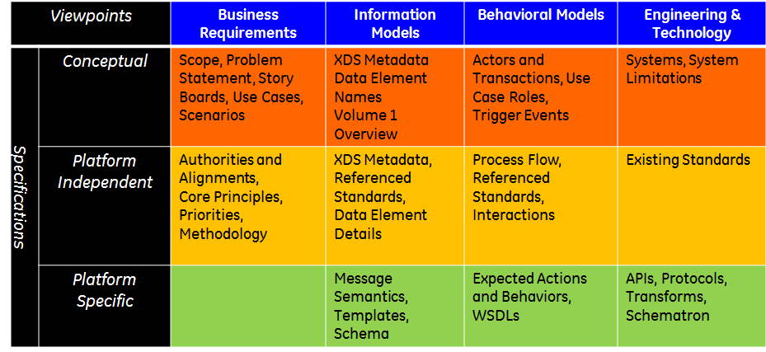

Fig 3-1: HL7 SAIF Approach applied to IHE process

# Conceptual

## Business Dimension

This section captures the business requirements including any policy constraints that need to be addressed by DAF. The DAF framework needs to address the following requirements which are based on the DAF User stories outlined in the Appendix.

* Enterprise Complexity:
  + Ability to query data present within an organization (Intra-enterprise)
  + Ability to query data from specific external organizations (Inter-enterprise)
  + Ability to query from multiple external organizations (Federated)
* Query Targets
  + Ability to query data about a single patient
  + Ability to query data about a patient population
* Query Granularity
  + Ability to query specific documents captured during workflows
  + Ability to query specific data contained within documents
  + Ability to query specific data captured and stored in multiple formats during clinical workflows
  + Ability to query pre-computed data (e.g. computations based on quality measures)
  + Ability to query aggregate data about a population
  + Ability to query a decision support knowledge artifact
* Query Response Granularity
  + Query Responses may contain metadata (e.g. links to documents, header information etc.)
  + Query Responses may contain clinical documents
  + Query Responses may contain discrete data
  + Query Responses may contain pre-computed data
  + Query Responses may contain aggregate data
* Security Aspects
  + Query interactions must be capable of protecting message integrity and confidentiality
  + Query interactions must be capable of being authenticated
  + Queries may require authorization before accessing data
  + Queries may require patient consent before allowing access to specific data elements
* Transport Requirements
  + Query interactions may need to use multiple transport protocols to enable systems of varying capabilities to interoperate with each other

## Information Dimension

The following section identifies the various conceptual data models that can be used to meet the DAF data requirements.

### Quality Improvement Domain Analysis Model (QIDAM)

The Health Quality Improvement Domain Analysis Model (QIDAM) seeks to create a conceptual data model that can be used to create data mapping expressions for electronic Clincial Quality Measures (eCQMs) and Clincial Decision Support (CDS) artifacts. QIDAM specifies the types of elements needed in the data model. More broadly, the primary purpose of the QIDAM is to serve as a model of clinical data within data mapping expressions, logical criteria, population criteria, formulae, and other expressions in health quality improvement artifacts. The QIDAM harmonizes the existing eCQM and CDS data models into a single, unified conceptual model. It is designed as an abstract fact model. This model can be mapped onto existing logical models while defining the structure and domain concepts required by eCQMs and CDS artifacts.

The latest HL7 QIDAM project and its related artifacts can be accessed at the following links, however UML diagrams are attached in the appendix for reference.

* Project Scope and relevant information
  + <http://wiki.hl7.org/index.php?title=Harmonization_of_Health_Quality_Information_models>
* Data Model
  + <https://github.com/cnanjo/OneModel/blob/master/harmonized/QIDAM.eap>
* Data Mapping and Harmonization Spreadsheets
  + <https://github.com/cnanjo/OneModel/blob/master/documents/QDM-vMR-cross-map.xlsx>

### Patient Demographics Model

The data model used to capture patient demographics at a conceptual level can be found as part of the HL7 v3 2013 normative edition which can be obtained at <http://www.hl7.org/implement/standards/product_brief.cfm?product_id=306>

The patient demographics model can be found with the normative edition in the following directories.

HL7_V3_NormativeEdition2013_2CDset/Edition2013_CD1/Edition2013/domains/uvpa/uvpa.html

Some of the conceptual data elements to be used are presented in the diagram below



Figure 4-1: Patient Demographics Conceptual Model

### Clinical Document Metadata Conceptual Model

The document metadata conceptual model is described in the [IHE ITI Technical Framework Volume](http://www.ihe.net/uploadedFiles/Documents/ITI/IHE_ITI_TF_Vol3.pdf) and will be used as a reference for further discussions throughout the document.

## Computation Dimension

The computation dimension captures the behavioral aspects and requirements of the system. This includes the various actors, roles, types of interactions, transactions that need to be supported along with the events that trigger the various interactions.

We will start out by describing the behavioral aspects of queries and then identify the actors, roles, events and DAF components.

### Query for data within Enterprise (Intra-Enterprise)

DAF queries can retrieve existing or computed data that is present within the enterprise. The query framework used to access data within an enterprise will be called Local Data Access Framework (LDAF) in this document. Security and Consent requirements for LDAF are controlled by the enterprise based on their internal data access policies.

### Query for data from Specific External Enterprise (Inter-Enterprise)

DAF queries can retrieve existing or computed data from a specific external enterprise. The query framework used to access data from specific external enterprise will be called Targeted Data Access Framework (TDAF) in this document. Targeted Data Access will need to ensure sufficient security controls (Authentication, Authorization etc.) are in place to allow data access from a specific external enterprise.

### Query for data from multiple external Enterprises (Federated)

DAF queries can retrieve existing or computed data from multiple external enterprises. The query framework used to access data from multiple external enterprises will be called Federated Data Access Framework (FDAF) in this document. Federated Data Access will need to ensure sufficient security controls (Authentication, Authorization etc.) are in place to allow data access from a multiple external enterprises.

### Query for Existing and Generated Documents

DAF queries can retrieve existing documents which are already present in repositories. These documents get created during clinical workflows and document the events, actions, instructions relevant to a patient’s encounter. DAF queries can also retrieve documents which are dynamically generated when the queries are executed by the responding system. In either case DAF queries will use the metadata about the documents such as creation time, type of document etc. to query for documents.

### Query for Existing and Computed Data

DAF queries can retrieve granular data (such as problems, medications, allergies) which are already present in repositories. The relevant data gets captured during clinical workflows and documents the information relevant to the patient. DAF queries can also retrieve data that is computed based on certain criteria about the data present in the system.

### DAF Abstract Model

The below diagram provides a very high level view of a DAF query along with the actors involved.

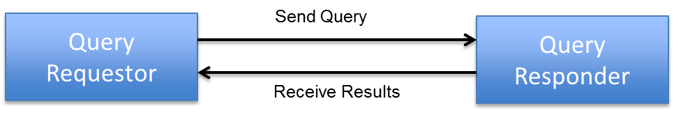

Figure 4-2: DAF Abstract Model

**Query Requestor:** The Query Requestor actor is a HealthIT system that is responsible for initiating a query on behalf of an end-user such as a provider, care-giver or another HealthIT system.

**Query Responder:** The Query Responder actor is a HealthIT system that is responsible for responding to a query request on behalf of the data holder and the data sources housing the response data.

Query Requestor and Query Responders will belong to the same enterprise for LDAF and in the case of Targeted DAF or Federated DAF; they will belong to different enterprises.

## Engineering Dimension

This section identifies the various existing IHE integration profiles that can be potentially used to implement the DAF use cases and requirements.

| Table 4-1: Existing IHE Profiles and their applicability to DAF | | | | | |
| --- | --- | --- | --- | --- | --- |
| IHE Profile | Summary | Applicability to | | | Notes |
| Local DAF | Targeted DAF | Federated DAF |
| [ATNA](http://wiki.ihe.net/index.php?title=Audit_Trail_and_Node_Authentication) | [Audit Trail and Node Authentication](http://wiki.ihe.net/index.php?title=Audit_Trail_and_Node_Authentication) Basic security through (a) functional node access controls (b) defined security audit logging and (c) secure network communications. | Y | Y | Y |  |
| [BPPC](http://wiki.ihe.net/index.php?title=Basic_Patient_Privacy_Consents) | [Basic Patient Privacy Consents](http://wiki.ihe.net/index.php?title=Basic_Patient_Privacy_Consents) method for recording a patient's privacy consent acknowledgement to be used for enforcing basic privacy appropriate to the use. | N | Y | Y | Consent may be required at the local level if the DAF framework is being used for Research purposes. |
| [DEX](http://wiki.ihe.net/index.php?title=Data_Element_Exchange) | [Data Element Exchange](http://wiki.ihe.net/index.php?title=Data_Element_Exchange) leverages the concept of a metadata registry to add mapping metadata to an annotated data capture form at the point of form design instead of the exchange of data instances. | N | N | N | Provides ability for model correspondence similar to USHIK, so it is useful for dynamic discovery of data elements, so it would not be applicable for DAF, but maybe useful before DAF comes into play. |
| [EUA](http://wiki.ihe.net/index.php?title=Enterprise_User_Authentication) | [Enterprise User Authentication](http://wiki.ihe.net/index.php?title=Enterprise_User_Authentication) enables single sign-on inside an enterprise by facilitating one name per user for participating devices and software. | Y | N | N |  |
| [HPD](http://wiki.ihe.net/index.php?title=Healthcare_Provider_Directory) | [Healthcare Provider Directory](http://wiki.ihe.net/index.php?title=Healthcare_Provider_Directory) supports discovery and management of healthcare provider information, both individual and organizational, in a directory structure. | N | N | Y | HPD may be useful to discover electronic addresses supporting queries. Becomes relevant in the federated case to perform discovery because in the first two cases the execution environment is static and well known. |
| [IUA](http://wiki.ihe.net/index.php?title=Internet_User_Authorization) | [Internet User Authorization](http://wiki.ihe.net/index.php?title=Internet_User_Authorization) provides user authorization for RESTful interface. | Y | Y | Y |  |
| [MHD](http://wiki.ihe.net/index.php?title=Mobile_access_to_Health_Documents) | [Mobile access to Health Documents](http://wiki.ihe.net/index.php?title=Mobile_access_to_Health_Documents) provides a RESTful interface to Document Sharing including XDS. | Y | Y | Y |  |
| [MPQ](http://wiki.ihe.net/index.php?title=Multi-Patient_Queries) | [Multi-Patient Queries](http://wiki.ihe.net/index.php?title=Multi-Patient_Queries) aggregates queries to a Document Registry for data analysis such as provider accreditation, clinical research trial data collection or population health monitoring. | Y | Y | Y |  |
| [PDQv3](http://wiki.ihe.net/index.php?title=Patient_Demographics_Query_HL7_v3) and PDQv2 | [Patient Demographics Query](http://wiki.ihe.net/index.php?title=Patient_Demographics_Query) lets applications query by patient demographics for patient identity from a central patient information server leveraging HL7 v3. | Y | Y | N | PIX/PDQ may be used across organizations based on legal and policy agreements to share patient identities. |
| [PIXv3](http://wiki.ihe.net/index.php?title=Patient_Identifier_Cross-Reference_HL7_v3) and PIXv2 | [Patient Identifier Cross Referencing](http://wiki.ihe.net/index.php?title=Patient_Identifier_Cross_Referencing) lets applications query for patient identity cross-references between hospitals, sites, health information exchange networks, etc. leveraging HL7 v3. | Y | Y | N | PIX/PDQ may be used across organizations based on legal and policy agreements to share patient identities. |
| [PWP](http://wiki.ihe.net/index.php?title=Personnel_White_Pages) | [Personnel White Pages](http://wiki.ihe.net/index.php?title=Personnel_White_Pages) provides basic directory information on human workforce members within an organization. | N | N | N |  |
| [QED](http://wiki.ihe.net/index.php?title=Query_for_Existing_Data_Profile) | [Query for Existing Data](http://wiki.ihe.net/index.php?title=Query_for_Existing_Data_Profile) queries data repositories for clinical information on vital signs, problems, medications, immunizations, and diagnostic results. | Y | Y | Y |  |
| [QME-EH](http://wiki.ihe.net/index.php?title=Quality_Measure_Execution-Early_Hearing) | [Quality Measure Execution-Early Hearing](http://wiki.ihe.net/index.php?title=Quality_Measure_Execution-Early_Hearing) describes the content needed to communicate patient-level data to electronically monitor the performance of early hearing-loss detection and intervention (EHDI) initiatives for newborns and young children. | N | N | N |  |
| [RID](http://wiki.ihe.net/index.php?title=Retrieve_Information_for_Display) | [Retrieve Information for Display](http://wiki.ihe.net/index.php?title=Retrieve_Information_for_Display) provides simple (browser-based) read-only access to clinical information (e.g. allergies or lab results). | Y | Y | Y | This is similar to MHD and could be useful to access limited data |
| [XCA](http://wiki.ihe.net/index.php?title=Cross-Community_Access) | [Cross-Community Access](http://wiki.ihe.net/index.php?title=Cross-Community_Access) allows querying and retrieving patient electronic health records held by other communities. | N | Y | Y | XCA deals with query federation across multiple sources, Between two organizations XDS can provide the same capability; however one could use XCA between two organizations. |
| [XCPD](http://wiki.ihe.net/index.php?title=Cross-Community_Patient_Discovery) | [Cross-Community Patient Discovery](http://wiki.ihe.net/index.php?title=Cross-Community_Patient_Discovery) supports locating communities with patient electronic health records and the translation of patient identifiers across communities. | N | Y | Y | Between two organizations PDQv2 or PDQv3 provides the same capability as XCPD. |
| [XDM](http://wiki.ihe.net/index.php?title=Cross-enterprise_Document_Media_Interchange) | [Cross-enterprise Document Media Interchange](http://wiki.ihe.net/index.php?title=Cross-enterprise_Document_Media_Interchange) transfers documents and metadata using CDs, USB memory, or email attachments. | Y | Y | Y |  |
| [XDR](http://wiki.ihe.net/index.php?title=Cross-enterprise_Document_Reliable_Interchange) | [Cross-enterprise Document Reliable Interchange](http://wiki.ihe.net/index.php?title=Cross-enterprise_Document_Reliable_Interchange) exchanges health documents between health enterprises using a web-service based point-to-point push network communication. | N | Y | Y | This could be useful for asynchronous queries such as Disability determination; this is unlikely to be used locally. |
| [XDS](http://wiki.ihe.net/index.php?title=Cross_Enterprise_Document_Sharing) | [Cross Enterprise Document Sharing](http://wiki.ihe.net/index.php?title=Cross_Enterprise_Document_Sharing) share and discover electronic health record documents between healthcare enterprises, physician offices, clinics, acute care in-patient facilities and personal health records. | Y | Y | N |  |
| [XDS-SD](http://wiki.ihe.net/index.php?title=Cross-enterprise_Sharing_of_Scanned_Documents) | [Cross-enterprise Sharing of Scanned Documents](http://wiki.ihe.net/index.php?title=Cross-enterprise_Sharing_of_Scanned_Documents) enables electronic records to be made from legacy paper, film, and other unstructured electronic documents. | Y | Y | N |  |
| [XDW](http://wiki.ihe.net/index.php?title=Cross_Enterprise_Workflow) | [Cross Enterprise Workflow](http://wiki.ihe.net/index.php?title=Cross_Enterprise_Workflow) coordinates human and applications mediated workflows across multiple organizations. | N | N | N | Workflow requirements are not in-scope for DAF |
| [XUA](http://wiki.ihe.net/index.php?title=Cross-Enterprise_User_Assertion) | [Cross-Enterprise User Assertion](http://wiki.ihe.net/index.php?title=Cross-Enterprise_User_Assertion) communicates claims about the identity of an authenticated principal (user, application, system...) across enterprise boundaries - Federated Identity. | N | Y | Y |  |

# Platform Independent Level

The section outlines the platform independent requirements related to the use of IHE profiles to support Data Access Framework requirements.

## 5.1 Business Dimension

The section outlines the business requirements for the platform independent viewpoint. The following business requirements are to be addressed by DAF.

* The specific queries that need to be supported by DAF are as follows:
  + Query patient data using document metadata which is captured as part of the documentation generated during clinical workflows (User Story #1, #2, #7)
  + Query Title 38 and other sensitive patient data using document metadata which is captured as part of the documentation generated during clinical workflows (User Story #3)
  + Query multiple patients data using document metadata which is captured as part of the documentation generated during clinical workflows (User Story #4)
  + Query patient data based on data present within their health records (User Story #5, #6, #9)
  + Query for the list of patients based on data present within their health records (User Story #8)
* User Stories [#1](#_User_Story#1(Document_meta), [#2](#_User_Story#2_(Document), [#3](#_User_Story#3_(Data), #5, #6, #7 and #9 need to be supported within the enterprise (LDAF) and across enterprises (TDAF or FDAF).
* User Stories #4 and #8 need to be supported within the enterprise (LDAF) at the current time.

## Information Dimension

This section captures the logical information models that will be used to implement the DAF. The logical information models identify the various data types, cardinality, relationships between the conceptual data elements identified previously in the Conceptual viewpoint.

### Document Metadata to be used for constructing queries

The section identifies the document metadata that will be used to formulate the queries. The DAF data elements are mapped to IHE XDS Metadata definitions as defined in [IHE ITI TF Vol 3](http://www.ihe.net/uploadedFiles/Documents/ITI/IHE_ITI_TF_Vol3.pdf).

|  |  |  |  |
| --- | --- | --- | --- |
| **Table 5-1: Document Metadata related to Time** | | | |
| **Data Set Selection** | **Generic Data Element[1]** | **Generic Data Element Description** | **XDS Metadata Mapping** |
| **Time** | Document Creation Time | Date and Time stamp for document creation. | XDSDocumentEntry- creationTime |
| Service Start Time | The start time the service being documented took place. | XDSDocumentEntry-serviceStartTime |
| Service End Time | The stop time the service being documented took place. | XDSDocumentEntry-serviceStopTime |

| **Table 5-2: Document Metadata related to Patient** | | | |
| --- | --- | --- | --- |
| **Data Set Selection** | **Generic Data Element[2]** | **Generic Data Element Description** | **XDS Metadata Mapping** |
| Patient Data | Patient ID | The identifier assigned by a provider or healthcare organization to a patient (example: MRN) | XDSDocumenEntry-patientId  (Not necessarily a MRN, it is based on how the affinity domain is setup), Within a facility it could be a MRN or if it is a HIE it could be HIE Id or in case of Federation it could be the cross community Id. |
| Patient Demographics | A set of demographic information about the patient. This information typically includes patient’s first and last name, sex, birth date, race, and ethnicity. | XDSDocumentEntry-sourcePatientInfo |
| Patient Identifiers | ID assigned to a patient where the care was provided within the local organization, if different from Patient ID. | XDSDocumentEntry – sourcePatientId for using MRN as the patient identifier. This will not work for SSN and Driver License # and other Ids. |

| **Table 5-3: Document Metadata related to Organization** | | | |
| --- | --- | --- | --- |
| **Data Set Selection** | **Generic Data Element[3]** | **Generic Data Element Description** | **XDS Metadata Mapping** |
| **Organization Data** | Author institution | Represents a specific healthcare facility where a document was authored. | XDSDocumentEntry – author - authorInstitution |
| Health Facility Information | Information about the organizational setting in which the clinical encounter was documented and where clinical act occurred. This includes (Name of facility, Type of facility, code of facility, ID of facility) | XDSDocumentEntry – author - authorInstitution |
| Source Organization Information | Information about the origin of the document (Name of the Organization, Type of organization Code of organization, ID of the organization ) | XDSDocumentEntry – authorInstitution for name of the facility, For type of the facility use healthcareFacilityTypeCode |
| Practice Setting Information | Practice setting is the location where clinical care was provided and the document was created. (Name of the practice, Code associated with the type of practice, identifier associated with the type of practice) e.g., Family Practice, Laboratory Department, Radiology Department, Pulmonary Unit, Intensive Care Unit, etc. | XDSDocumentEntry - practiceSettingCode |
| Document Custodian | Organization legally responsible for the document | Not mapped by the metadata accurately. (Most of the time it is the SubmissionSet Source, however for accurate information, you have to access the document header) |

|  |  |  |  |
| --- | --- | --- | --- |
| **Table 5-4: Document Metadata related to Document types, Ids.** | | | |
| **Data Set Selection** | **Generic Data Element[4]** | **Generic Data Element Description** | **XDS Metadata Mapping** |
| **Document Level Data** | Document Information | Information about the document where patient information has been recorded (code associated with document type, Name associated with the document type, IDs associated with the document) | XDSDocument Entry – typeCode for type of the document (800 or 900 types exist currently)  Use classCode to deal with lesser number of document types since they are of a higher granularity.  XDSDocumentEntry – uniqueId for IDs  For Document Name use XDSDocumentEntry - typeCodedisplayName |
| Comments | Comments associated with the Document, free form text. | XDSDocumentEntry – comments for comments, |

|  |  |  |  |
| --- | --- | --- | --- |
| **Table 5-5: Document Metadata related to Document Author** | | | |
| **Data Set Selection** | **Generic Data Element[5]** | **Generic Data Element Description** | **XDS Metadata Mapping** |
| **Document Author** | Author Specialty | Represents a specific specialty of the author who created the document. For example, Primary Care Physician, Nurse Practitioner, Anesthesiologist, Cardiologist etc. | XDSDocumentEntry – authorSpecialty |
| Author Contact Information | Represents the telecommunications address (e.g. phone, email, etc.) of the document author, intended to assist with automated routing of other messages intended for the document author. | XDSDocumentEntry – authorTelecommunication |

### Data Elements to be used for constructing queries

The section identifies the data elements that will be used to formulate the queries. The conceptual data elements are mapped to C-CDA R2 based definitions. The table is using the “.” symbol to identify the specific sub-element within C-CDA R2 data elements[6].

| **Table 5-6: Data Elements to be used for constructing queries** | |
| --- | --- |
| **Data Elements** | **Detailed Data Element definitions to be used for queries based on C-CDA** |
| Patient (s) Identification | RecordTarget.PatientRole.id |
| Facility / Source | componentOf.encompassingEncounter.location |
| Encounter Type | Entry.encounter.code |
| Date (Date Range) | documentationOf.serviceEvent.effectiveTime (low and high) |
| 1. Patient name | recordTarget.patientRole.Patient.name |
| 2. Sex | recordTarget.patientRole.Patient.administrativeGenderCode |
| 3. Date of birth | recordTarget.patientRole.Patient.birthTime |
| 4. Race | recordTarget.patientRole.Patient.raceCode |
| 5. Ethnicity | recordTarget.patientRole.Patient.ethnicGroupCode |
| 6. Preferred language | recordTarget.patientRole.Patient.languageCommunication |
| 7. Smoking status | SmokingStatusObservation.Value  SmokingStatusObservation.EffectiveTime |
| 8. Problems | ProblemObservation.Value  ProblemObservation.EffectiveTime  ProblemObservation.ProblemStatus.Value  ProblemObservation.AgeObservation.Value |
| 9. Medications | MedicationActivity.EffectiveTime  MedicationActivity.Consumable.ManufacturedProduct.ManufacturedMaterial.Code |
| 10. Medication allergies | AllergyIntoleranceObservation.EffectiveTime  AllergyIntoleranceObservation.Value  AllergyIntoleranceObservation.Participant.ParticipantRole.PlayingEntity.Code  AllergyIntoleranceObservation.AllergyStatusObservation.Value  AllergyIntoleranceObservation.AllergyReactionObservation.Value  AllergyIntoleranceObservation.SeverityObservation.Value |
| 11. Laboratory test(s) | ResultOrganizer.Code |
| 12. Laboratory value(s)/result(s) | ResultObservation.Code  ResultObservation.Value  ResultObservaton.EffectiveTime |
| 13. Vital signs (height, weight, BP, BMI) | VitalSignsObservation.Code  VitalSignsObservation.Value  VitalSignsObservation.EffectiveTime |
| 14. Care plan field(s), including goals and instructions | MU2 does not require structured entries, so free text searches will be required. |
| 15. Procedures | ProcedureActivityProcedure.Code  ProcedureActivityProcedure.EffectiveTime |
| 16. Care team members | This information could be present in multiple locations in the C-CDA documents. |
| 17. Immunizations | ImmunizationActivity.Consumable.ManufacturedProduct.ManufacturedMaterial.Code  ImmunizationActivity.EffectiveTime |
| 18. Confidentiality Information | ClinicalDocument.ConfidentialityCode |
| 19. Clinical Instructions[7] | MU2 does not require structured entries, so free text searches will be required. |
| 20. Cognitive Status | Cognitive Status Result Observation.Code |
| 21. Date and Location of Visit | componentOf.EncompassingEncounter.EffectiveTime  componentOf.EncompassingEncounter.location |
| 22. Dates and Location of Admission and Discharge- Inpatient Only | componentOf.EncompassingEncounter.EffectiveTime  componentOf.EncompassingEncounter.location |
| 23. Diagnostic Tests Pending | MU2 does not require structured entries, so free text searches will be required. |
| 24. Discharge Instructions- Inpatient Only | MU2 does not require structured entries, so free text searches will be required. |
| 25. Functional Status | MU2 does not require structured entries, so free text searches will be required. |
| 26. Future Appointments | MU2 does not require structured entries, so free text searches will be required. |
| 27. Future Scheduled Tests | MU2 does not require structured entries, so free text searches will be required. |
| 28. Immunizations Administered during the Visit* | Similar to Immunizations above. |
| 29. Medication List * | Similar to Medications above. |
| 30. Medications Administered during the Visit* | Similar to Medications above. |
| 31. Provider Name and Office Contact Information | Can be present in multiple locations in CDA documents. |
| 32. Reason for Hospitalization- Inpatient Only | MU2 does not require structured entries, so free text searches will be required. |
| 33. Reason for Referral- Ambulatory Only | MU2 does not require structured entries, so free text searches will be required. |
| 34. Reason for Visit | MU2 does not require structured entries, so free text searches will be required. |
| 35. Recommended Patient Decision Aids | MU2 does not require structured entries, so free text searches will be required. |
| 36. Referrals to other Providers | MU2 does not require structured entries, so free text searches will be required. |

### Data Elements to be included in Query Responses

This section outlines the data elements to be used to represent query responses.

|  |  |
| --- | --- |
| **Table 5-7: Query Response Data Elements** | |
| **Data Elements** | **Data Elements to be used in Query Responses** |
| Patient Information including demographics, Ids and other attributes | Patient Id, Name, Sex, Date of Birth, Race, Ethnicity, Gender, Preferred Language based on C-CDA definitions |
| Document Link identifying the document uniquely for future access | HomeCommunityId/RepositoryUniqueId/Document Id  Or URI based on XDSDocumentEntry Metadata definitions |
| Clinical Documents with necessary information | [C-CDA R1.1](http://www.google.com/url?q=http%3A%2F%2Fwww.hl7.org%2Fdocumentcenter%2Fpublic%2Fstandards%2Fdstu%2FCDAR2_IG_IHE_CONSOL_DSTU_R1dot1_2012JUL.zip&sa=D&sntz=1&usg=AFQjCNHl-fqX1zd9abZYLPzwgdEvik3EvA) based clinical documents. |
| Individual Data Element such as Medications, Allergies, Lab Results etc. | Un-reconciled information about the patient based on CDA Clinical statements and document sections. |

## Computation Dimension

The following types of query patterns will be supported by DAF for the identified user stories

### Synchronous Queries

Synchronous queries are those where a query requestor sends a request to a query responder and waits for the responder to provide a response to the query. Synchronous queries are used when the requestor requires an immediate response and is willing to wait for the response. DAF is expected to use synchronous queries widely for patient level information.

### Asynchronous Queries

Asynchronous queries are those where a query requestor submits a request to a query responder and continues to perform other tasks without waiting for a response. The query responder will provide a response after it completes the necessary processing. Typically asynchronous queries are used when the query response are expected to be delayed due to workflow and processing complexities. DAF is expected to use asynchronous queries whenever responses are expected to be delivered at a later time based on workflow and processing requirements.

### Query Execution Context and Security

The following security aspects are applicable for the queries based on the query execution context.

#### Local DAF

For Local Data Access Framework, the enterprise controlling the Query Requestor and Query Responder HealthIT systems will prescribe appropriate security controls based on local policies.

#### Targeted DAF and Federated DAF

In the case of both Targeted and Federated Data Access Framework, queries are executed across enterprises belonging to different security domains. In order for these queries to be executed, appropriate security information (Authentication, Authorization etc.) needs to be included as part of the query request.

### DAF Queries

This section describes the various queries[8] that need to be supported based on the user stories and the data elements documented in the appendices of the document.

#### Find Patient Identifiers for Patient Demographics

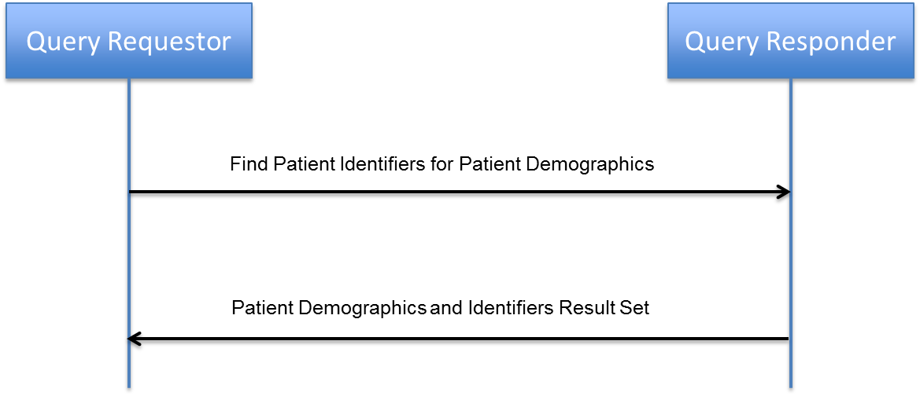

Figure 5-1: Find Patient Identifiers for Patient Demographics Query

The following table[9] provides query request and response information that needs to be supported by the query.

|  |  |  |  |  |
| --- | --- | --- | --- | --- |
| **Table 5-8: Request/Response information for Find Patient Identifiers** | | | | |
| **Query Request Information** | **Query Response Information** | **DAF Applicability** | | |
| **LDAF** | **TDAF** | **FDAF** |
| Required data elements: Patient Name, Birth Date  Optional data elements: Gender, Patient Address, Birthplace Address, Patient Telecom, Mother’s Maiden Name, etc. | List of Patient Identifiers that uniquely identify the patient based on patient matching results along with the demographics that were used to match the patient. | Yes | Yes | Yes |

#### Find Document(s) based on Patient Identifiers

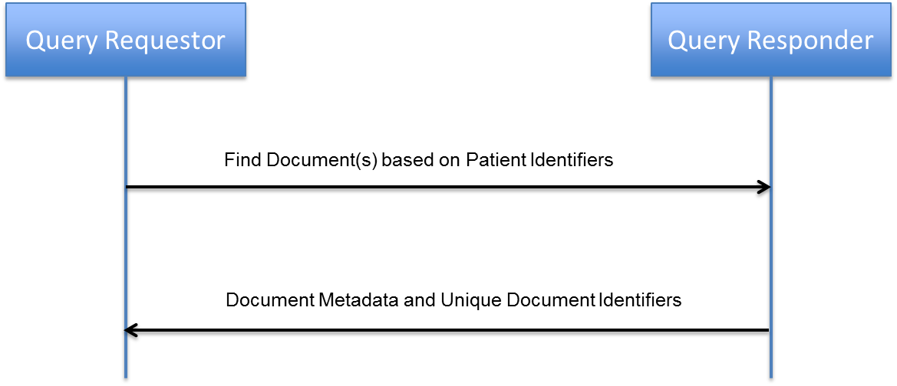

Figure 5-2: Find Document(s) based on Patient Identifiers Query

The following table provides query request and response information that needs to be supported by the query

|  |  |  |  |  |
| --- | --- | --- | --- | --- |
| **Table 5-9: Request/Response information for Find Document(s) using Patient Identifiers** | | | | |
| **Query Request Information** | **Query Response Information** | **DAF Applicability** | | |
| **LDAF** | **TDAF** | **FDAF** |
| Required data elements: Unique Patient Identifier known to the Query Responder  Optional data elements: Document metadata such as author, creation time etc. | List of Unique Document Identifiers for subsequent document retrieval and related document metadata. | Yes | Yes | Yes |

#### Get Document(s) based on Document Identifiers

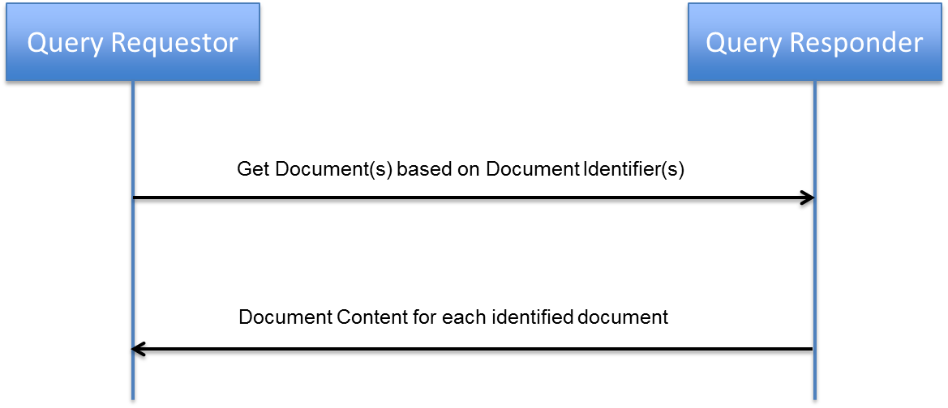

Figure 5-3: Get Document(s) based on Document Identifiers Query

The following table provides query request and response information that needs to be supported by the query

|  |  |  |  |  |
| --- | --- | --- | --- | --- |
| **Table 5-10: Request/Response information for Get Document(s) based on Document Ids** | | | | |
| **Query Request Information** | **Query Response Information** | **DAF Applicability** | | |
| **LDAF** | **TDAF** | **FDAF** |
| Required data elements: Unique Document Identifier known to the Query Responder | Document content for each identified document using C-CDA R1.1 data elements | Yes | Yes | Yes |

#### Get data based on Patient data and clinical data elements

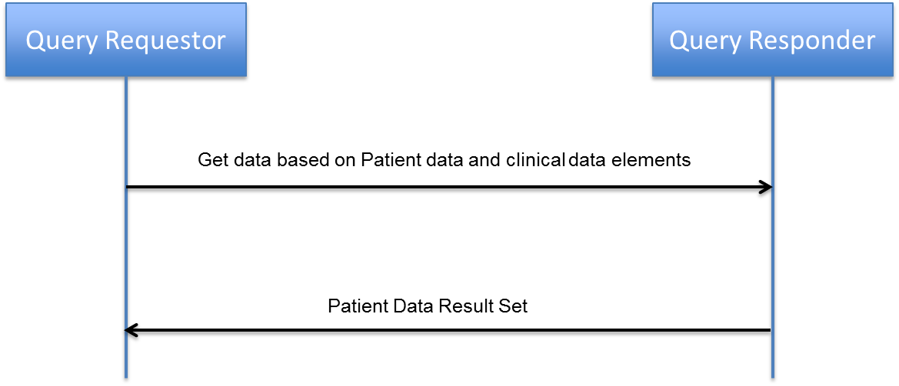

Figure 5-4: Get data based on clinical data elements

The following table provides query request and response information that needs to be supported by the query

|  |  |  |  |  |
| --- | --- | --- | --- | --- |
| **Table 5-11: Request/Response information for Get data based on clinical data elements** | | | | |
| **Query Request Information** | **Query Response Information** | **DAF Applicability** | | |
| **LDAF** | **TDAF** | **FDAF** |
| Required data elements: Patient Identifier or Patient Demographics (Patient Name, Gender, Birth Date)  Optional data elements: Clinical data elements related to one of the following (vital signs, problems, allergies, medications, immunizations, lab results, procedures or encounters) | Data Elements corresponding to the requested data Patient information, encounter information and optionally clinical information related to one of the following(vital signs, problems, allergies, medications, immunizations, lab results, procedures) | Yes | Yes | Yes |

#### Find Document(s) based on Patient Demographics

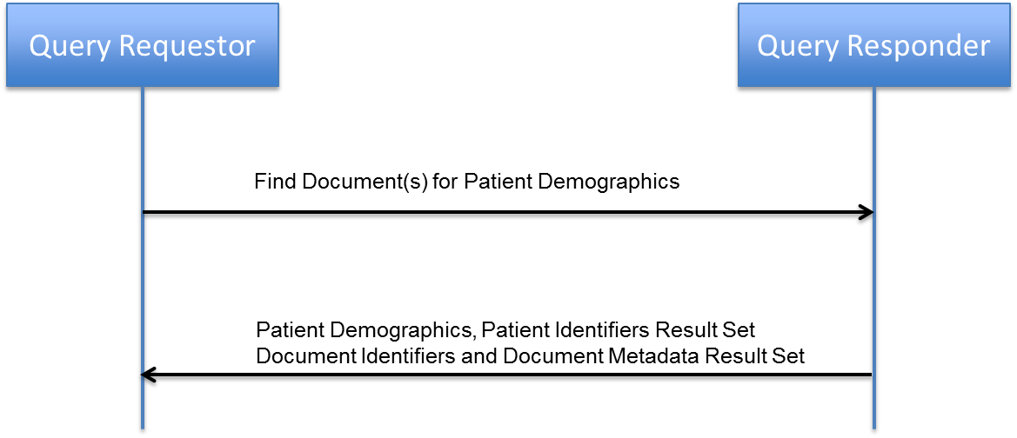

Figure 5-5: Find Document(s) based on Patient Demographics

The following table provides query request and response information that needs to be supported by the query

|  |  |  |  |  |
| --- | --- | --- | --- | --- |
| **Table 5-12: Request/Response information for Find Document(s) based on Patient Demographics** | | | | |
| **Query Request Information** | **Query Response Information** | **DAF Applicability** | | |
| **LDAF** | **TDAF** | **FDAF** |
| Required data elements: Patient Name, Birth Date  Optional data elements: Gender, Patient Address, Birthplace Address, Patient Telecom, Mother’s Maiden Name, etc. | List of Patient Identifiers that uniquely identify the patient based on patient matching results along with the demographics that were used to match the patient.  List of Unique Document Identifiers for subsequent document retrieval and related document metadata. | Yes | Yes | Yes |

#### Find Document(s) based on Multiple Patient Identifiers

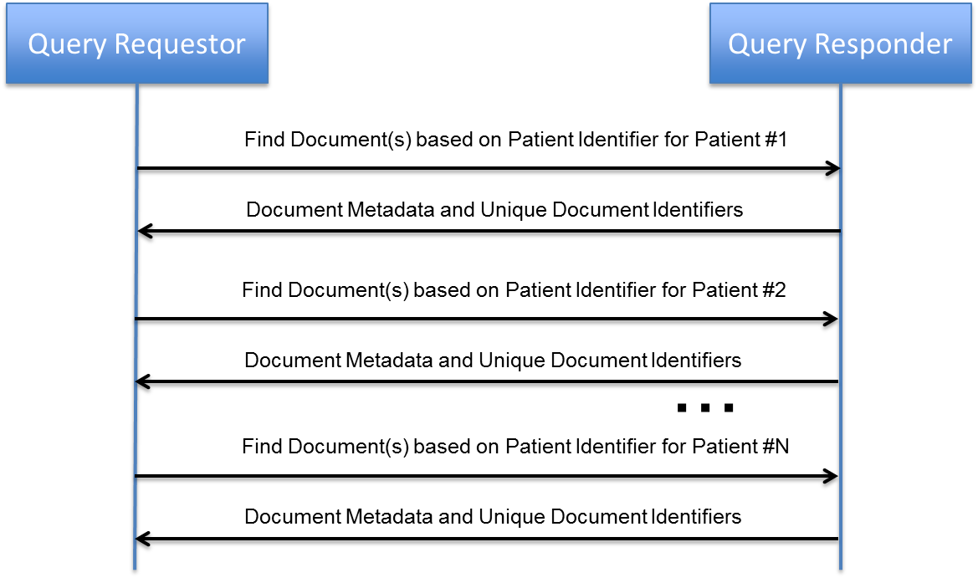

Figure 5-6: Find Document(s) based on Multiple Patient Identifiers

In order to find documents for multiple patients, the [Find Document(s) based on Patient Identifiers](#_Find_Document(s)_based) query is executed repeatedly as shown in the above sequence diagram.

#### Get Population Data based on clinical data elements

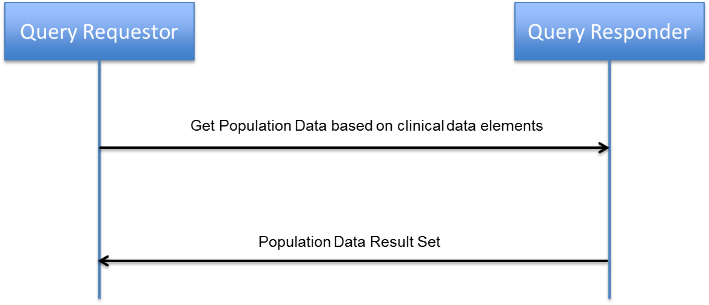

Figure 5-7: Get Population data based on clinical data elements

The following table provides query request and response information that needs to be supported by the query

|  |  |  |  |  |
| --- | --- | --- | --- | --- |
| **Table 5-13: Request/Response information for Get Population data based on clinical data elements** | | | | |
| **Query Request Information** | **Query Response Information** | **DAF Applicability** | | |
| **LDAF** | **TDAF** | **FDAF** |
| Required data elements: Query criteria based on clinical data elements | Population data based on the query clinical data elements. | Yes | No | No |

The above query can be used to create the list of patients based on specific clinical data elements. The query can also be used to just get aggregate counts of patients that meet the criteria specified using the clinical data elements.

#### Support Capability: Supply and Consume User Assertions

User Assertions capability is not a query but it is typically required by in a Targeted and Federated DAF query. So this capability is called a support capability and will be used with different queries as necessary.

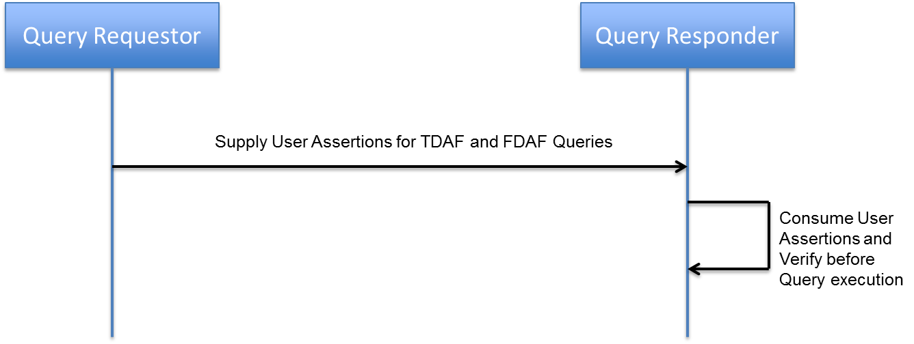

Figure 5-8: Supply and Consumer User Assertions capability

As shown in the above diagram, the Query Requestor has to supply the required User Assertion to the Query Responder. The Query Responder will consume the User Assertions and perform the required verification before allowing queries to be executed. The data that can be exchanged as part of the User Assertions include

* Identity of the person requesting the information
* Role of the User accessing the information
* Purpose of Use for accessing the information
* Any consent information that can be provided as necessary.

## Engineering Dimension

The section outlines the candidate IHE profiles that can be used to meet the outlined queries, data elements and data structures from the list of previously identified IHE profiles.

| **Table 5-14: Mapping of IHE Profiles for the different DAF Queries** | | | |
| --- | --- | --- | --- |
| **Query Name** | **IHE Profile Mapping for LDAF** | **IHE Profile Mapping for TDAF** | **IHE Profile Mapping for FDAF** |
| Find Patient Identifiers for Patient Demographics | [PIX/PDQv3](http://wiki.ihe.net/index.php?title=Patient_Demographics_Query_HL7_v3) - ITI 45, ITI 47  PDQM (Still under construction) | [PIX/PDQv3](http://wiki.ihe.net/index.php?title=Patient_Demographics_Query_HL7_v3) - ITI 45, ITI 47  [XCPD](http://wiki.ihe.net/index.php?title=Cross-Community_Patient_Discovery) – ITI 55 | [XCPD](http://wiki.ihe.net/index.php?title=Cross-Community_Patient_Discovery) – ITI 55 |
| Find Document(s) based on Patient Identifiers | [XDS](http://wiki.ihe.net/index.php?title=Cross_Enterprise_Document_Sharing) **–** ITI 18  [MHD](http://wiki.ihe.net/index.php?title=Mobile_access_to_Health_Documents) **–** ITI 66, ITI 67 | [XDS](http://wiki.ihe.net/index.php?title=Cross_Enterprise_Document_Sharing) **–** ITI 18  [XCA](http://wiki.ihe.net/index.php?title=Cross-Community_Access) - ITI 38 | [XCA](http://wiki.ihe.net/index.php?title=Cross-Community_Access) - ITI 38 |
| Get Document(s) based on Document Identifiers | [XDS](http://wiki.ihe.net/index.php?title=Cross_Enterprise_Document_Sharing) **–** ITI 43  [MHD](http://wiki.ihe.net/index.php?title=Mobile_access_to_Health_Documents) **–** ITI 68 | [XDS](http://wiki.ihe.net/index.php?title=Cross_Enterprise_Document_Sharing) **–** ITI 43  [XCA](http://wiki.ihe.net/index.php?title=Cross-Community_Access) - ITI 39 | [XCA](http://wiki.ihe.net/index.php?title=Cross-Community_Access) - ITI 39 |
| Get data based on Patient Data and clinical data elements | [QED](http://wiki.ihe.net/index.php?title=Query_for_Existing_Data_Profile) – PCC-1, All options  Gap – for some data elements and free text search and data responses. | [QED](http://wiki.ihe.net/index.php?title=Query_for_Existing_Data_Profile) – PCC-1, All options.  Gap – for some data elements and free text search and data responses. | [QED](http://wiki.ihe.net/index.php?title=Query_for_Existing_Data_Profile) – PCC-1, All options  Gap – for some data elements and free text search and data responses. |
| Find Document(s) based on Patient Demographics | Gap | Gap | Gap |
| Find Document(s) based on multiple Patient Identifiers | Same Profile/Transaction pairs as Find Document(s) based on Patient Identifiers | Same Profile/Transaction pairs as Find Document(s) based on Patient Identifiers | Same Profile/Transaction pairs as Find Document(s) based on Patient Identifiers |
| Get Population data based on clinical data elements | Gap | Gap | Gap |
| Supply and Consume User Assertions | Left to the discretion of the enterprise. | [XUA](http://wiki.ihe.net/index.php?title=Cross-Enterprise_User_Assertion) – ITI 40  [IUA](http://wiki.ihe.net/index.php?title=Internet_User_Authorization) - ITI Y1, ITI Y3  [BPPC](http://wiki.ihe.net/index.php?title=Basic_Patient_Privacy_Consents) | [XUA](http://wiki.ihe.net/index.php?title=Cross-Enterprise_User_Assertion) – ITI 40  [IUA](http://wiki.ihe.net/index.php?title=Internet_User_Authorization) - ITI Y1, ITI Y3  [BPPC](http://wiki.ihe.net/index.php?title=Basic_Patient_Privacy_Consents) |

# Platform Specific Level

This section outlines the platform specific bindings that enable the use of IHE profiles to support Data Access Framework requirements.

We briefly discuss various platform-specific transport stacks that can potentially be used by DAF.

***Transport stack1: Queries using HTTP and SOAP (SOAP stack)***

Many of the existing IHE profiles use HTTP as the transport, along with appropriate SOAP protocols to perform queries. SOAP protocols use XML structure to package content. Within the XML package other structural standards and formats are leveraged to further define data structures. Some of these additional standards that are leveraged include ebRIM, SAML, DSML etc.

***Transport stack2: Queries using HTTP and RESTful resources (Restful stack)***

Some of the emerging IHE profiles are using HTTP as the transport, along with RESTful resources to perform queries. The RESTful resources are using JSON structure to package content. Within the JSON package other structural standards and formats are leveraged to further define data structures. Some of these additional standards that are leveraged include OAuth2 and in the future HL7 FHIR.

***Transport stack3: Queries using MLLP and HL7 V2 (MLLP stack)***

The **Lower Layer Protocol (LLP),** sometimes referred to as the **Minimal Lower Layer Protocol (MLLP)**, is a standard for transmitting HL7 messages via TCP/IP. Since TCP/IP is a continuous stream of bytes, a wrapping protocol is required for communications code to be able to recognize the start and the end of each message. The Lower Layer Protocol is the most common mechanism for sending unencrypted HL7 via TCP/IP over a local area network, such as those found in a hospital. The HL7 messages further use specific delimiters and structures to encode the data within the message.

***Transport stack4: Queries using SMTP and S/MIME (SMTP stack)***

Currently there is limited use of SMTP (IHE XDM profile has an SMTP option) stack for queries to enable data access; however the SMTP stack could play a significant role for asynchronous query implementation. A derivative of the SMTP stack (i.e. Direct) is required for Meaningful Use stage 2 in the US due to which many EMR systems are supporting the STMP stack as one of the protocols to enable push based messaging. The S/MIME standard is used to structure the package in the SMTP stack. The package itself leverages other standards and formats to further define the data structures.

## 6.1 Business Dimension

* Allow for substitutability of transport stacks
  + Vendor systems implement different transport stacks. Examples of transport stacks include (HTTP + SOAP, HTTP + RESTful resources, MLLP + ER7 etc.). Interoperability across the transport stacks is a challenge, however allowing for defined ways to substitute transport stacks will provide greater levels of interoperability.
* Design for a modular Query stack
  + In order to enable flexibility in the usage of multiple transport, content and security standards it is important for DAF to modularize the query stack with defined APIs that allow for substitution.
* Allow for substitutability of content standards
  + The content that is exchanged using the various transport stacks vary widely and requires specific bindings based on the transport stack to enable interoperable exchange. The DAF use cases will use multiple content standards and profiles, and are expected to evolve over time.

## Information Dimension

The following table identifies the queries and the corresponding IHE profiles which can be used to implement the various queries. The Queries will be structured based on the specific profile requirements as outlined in the table and the schemas and WSDL’s will not be repeated in this document.

| **Table 6-1: Mapping of Query Name to concrete Schemas and WSDL’s based on existing IHE Profiles** | | | |
| --- | --- | --- | --- |
| **Query Name** | **IHE Profile Mapping for LDAF** | **IHE Profile Mapping for TDAF** | **IHE Profile Mapping for FDAF** |
| Find Patient Identifiers for Patient Demographics | [PIX/PDQv3](http://wiki.ihe.net/index.php?title=Patient_Demographics_Query_HL7_v3) - ITI 45, ITI 47  PDQM (Still under construction) | [PIX/PDQv3](http://wiki.ihe.net/index.php?title=Patient_Demographics_Query_HL7_v3) - ITI 45, ITI 47  [XCPD](http://wiki.ihe.net/index.php?title=Cross-Community_Patient_Discovery) – ITI 55 | [XCPD](http://wiki.ihe.net/index.php?title=Cross-Community_Patient_Discovery) – ITI 55 |
| Find Document(s) based on Patient Identifiers | [XDS](http://wiki.ihe.net/index.php?title=Cross_Enterprise_Document_Sharing) **–** ITI 18  [MHD](http://wiki.ihe.net/index.php?title=Mobile_access_to_Health_Documents) **–** ITI 66, ITI 67 | [XDS](http://wiki.ihe.net/index.php?title=Cross_Enterprise_Document_Sharing) **–** ITI 18  [XCA](http://wiki.ihe.net/index.php?title=Cross-Community_Access) - ITI 38 | [XCA](http://wiki.ihe.net/index.php?title=Cross-Community_Access) - ITI 38 |
| Get Document(s) based on Document Identifiers | [XDS](http://wiki.ihe.net/index.php?title=Cross_Enterprise_Document_Sharing) **–** ITI 43  [MHD](http://wiki.ihe.net/index.php?title=Mobile_access_to_Health_Documents) **–** ITI 68 | [XDS](http://wiki.ihe.net/index.php?title=Cross_Enterprise_Document_Sharing) **–** ITI 43  [XCA](http://wiki.ihe.net/index.php?title=Cross-Community_Access) - ITI 39 | [XCA](http://wiki.ihe.net/index.php?title=Cross-Community_Access) - ITI 39 |
| Get data based on Patient Data and clinical data elements | [QED](http://wiki.ihe.net/index.php?title=Query_for_Existing_Data_Profile) – PCC-1, All options  Gap – for some data elements and free text search and data responses. | [QED](http://wiki.ihe.net/index.php?title=Query_for_Existing_Data_Profile) – PCC-1, All options  Gap – for some data elements and free text search and data responses. | [QED](http://wiki.ihe.net/index.php?title=Query_for_Existing_Data_Profile) – PCC-1, All options  Gap – for some data elements and free text search and data responses. |
| Find Document(s) based on Patient Demographics | Gap | Gap | Gap |
| Find Document(s) based on multiple Patient Identifiers | Same Profile/Transaction pairs as Find Document(s) based on Patient Identifiers | Same Profile/Transaction pairs as Find Document(s) based on Patient Identifiers | Same Profile/Transaction pairs as Find Document(s) based on Patient Identifiers |
| Find Population data based on clinical data elements | Gap | Gap | Gap |
| Supply and Consume User Assertions | Left to the discretion of the enterprise. | [XUA](http://wiki.ihe.net/index.php?title=Cross-Enterprise_User_Assertion) – ITI 40  [IUA](http://wiki.ihe.net/index.php?title=Internet_User_Authorization) - ITI Y1, ITI Y3  [BPPC](http://wiki.ihe.net/index.php?title=Basic_Patient_Privacy_Consents) | [XUA](http://wiki.ihe.net/index.php?title=Cross-Enterprise_User_Assertion) – ITI 40  [IUA](http://wiki.ihe.net/index.php?title=Internet_User_Authorization) - ITI Y1, ITI Y3  [BPPC](http://wiki.ihe.net/index.php?title=Basic_Patient_Privacy_Consents) |

**Document Structure for Query Results using XDS, XCA or MHD:**

The document results that will be returned will be structured using [C-CDA R1.1](http://www.google.com/url?q=http%3A%2F%2Fwww.hl7.org%2Fdocumentcenter%2Fpublic%2Fstandards%2Fdstu%2FCDAR2_IG_IHE_CONSOL_DSTU_R1dot1_2012JUL.zip&sa=D&sntz=1&usg=AFQjCNHl-fqX1zd9abZYLPzwgdEvik3EvA).

## Computational Dimension

The section outlines the platform specific profile combinations that will further interoperability of queries and provide the needed flexibility to evolve transport, security and content standards.

## Actors and Transactions

The section identifies the actors and transactions that need to be supported for LDAF, TDAF and FDAF. Each query that was outlined will be referred to as a transaction for the purposes of discussion going forward.

#### Actors/Transaction Requirements for LDAF

The following table identifies the actors, the corresponding transport stack, security options and content profiles for LDAF

| **Table 6-2: Actor/Transaction Requirements for Local DAF** | | | | |
| --- | --- | --- | --- | --- |
| **Actor** | **Transaction (Query) Name** | **SOAP/REST** | **Optionality** | **IHE Profile Mapping for LDAF** |
| Query Requestor | Find Patient Identifiers for Patient Demographics | SOAP | R | [PIX/PDQv3](http://wiki.ihe.net/index.php?title=Patient_Demographics_Query_HL7_v3) - ITI 45, ITI 47 |
| REST | O | PDQM (Still under construction) |
| Find Document(s) based on Patient Identifiers (At least one of the options need to be supported) | SOAP | O | [XDS](http://wiki.ihe.net/index.php?title=Cross_Enterprise_Document_Sharing) **–** ITI 18 |
| REST | O | [MHD](http://wiki.ihe.net/index.php?title=Mobile_access_to_Health_Documents) **–** ITI 66, ITI 67 |
| Get Document(s) based on Document Identifiers (At least one of the options need to be supported) | SOAP | O | [XDS](http://wiki.ihe.net/index.php?title=Cross_Enterprise_Document_Sharing) **–** ITI 43 |
| REST | O | [MHD](http://wiki.ihe.net/index.php?title=Mobile_access_to_Health_Documents) **–** ITI 68 |
| Get data based on Patient Data and clinical data elements | SOAP | R | [QED](http://wiki.ihe.net/index.php?title=Query_for_Existing_Data_Profile) – PCC-1, All options  Gap for some data elements. |
| REST | N/A | Gap |
| Find Document(s) based on Patient Demographics | SOAP | N/A | Gap |
| REST | N/A | Gap |
| Find Population data based on clinical data elements | SOAP | N/A | Gap |
| REST | N/A | Gap |
| Supply and Consume User Assertions | SOAP | O | [XUA](http://wiki.ihe.net/index.php?title=Cross-Enterprise_User_Assertion) – ITI 40  [BPPC](http://wiki.ihe.net/index.php?title=Basic_Patient_Privacy_Consents) |
| REST | O | [IUA](http://wiki.ihe.net/index.php?title=Internet_User_Authorization) - ITI Y1, ITI Y3 |
| Query Responder | Find Patient Identifiers for Patient Demographics | SOAP | R | [PIX/PDQv3](http://wiki.ihe.net/index.php?title=Patient_Demographics_Query_HL7_v3) - ITI 45, ITI 47 |
| REST | R | PDQM (Still under construction) |
| Find Document(s) based on Patient Identifiers | SOAP | R | [XDS](http://wiki.ihe.net/index.php?title=Cross_Enterprise_Document_Sharing) **–** ITI 18 |
| REST | R | [MHD](http://wiki.ihe.net/index.php?title=Mobile_access_to_Health_Documents) **–** ITI 66, ITI 67 |
| Get Document(s) based on Document Identifiers | SOAP | R | [XDS](http://wiki.ihe.net/index.php?title=Cross_Enterprise_Document_Sharing) **–** ITI 43 |
| REST | R | [MHD](http://wiki.ihe.net/index.php?title=Mobile_access_to_Health_Documents) **–** ITI 68 |
| Get data based on Patient Data and clinical data elements | SOAP | R | [QED](http://wiki.ihe.net/index.php?title=Query_for_Existing_Data_Profile) – PCC-1, All options  Gap for some data elements. |
| REST | N/A | Gap |
| Find Document(s) based on Patient Demographics | SOAP | N/A | Gap |
| REST | N/A | Gap |
| Find Population data based on clinical data elements | SOAP | N/A | Gap |
| REST | N/A | Gap |
| Supply and Consume User Assertions | SOAP | R | [XUA](http://wiki.ihe.net/index.php?title=Cross-Enterprise_User_Assertion) – ITI 40  [BPPC](http://wiki.ihe.net/index.php?title=Basic_Patient_Privacy_Consents) |
| REST | R | [IUA](http://wiki.ihe.net/index.php?title=Internet_User_Authorization) - ITI Y1, ITI Y3 |

#### Actors/Transaction Requirements for TDAF

The following table identifies the actors, the corresponding transport stack, security options and content profiles for TDAF.

| **Table 6-4: Actors/Transaction Requirements for Targeted DAF** | | | | |
| --- | --- | --- | --- | --- |
| **Actor** | **Query Name** | **SOAP/REST** | **Required/Optional** | **IHE Profile Mapping for TDAF** |
| Query Requestor | Find Patient Identifiers for Patient Demographics | SOAP | R | [PIX/PDQv3](http://wiki.ihe.net/index.php?title=Patient_Demographics_Query_HL7_v3) - ITI 45, ITI 47  [XCPD](http://wiki.ihe.net/index.php?title=Cross-Community_Patient_Discovery) – ITI55 |
| REST | N/A | Gap |
| Find Document(s) based on Patient Identifiers (At least one of the options need to be supported) | SOAP | R | [XDS](http://wiki.ihe.net/index.php?title=Cross_Enterprise_Document_Sharing) **–** ITI 18  [XCA](http://wiki.ihe.net/index.php?title=Cross-Community_Access) - ITI 38 |
| REST | N/A | Gap |
| Get Document(s) based on Document Identifiers (At least one of the options need to be supported) | SOAP | R | [XDS](http://wiki.ihe.net/index.php?title=Cross_Enterprise_Document_Sharing) **–** ITI 43  [XCA](http://wiki.ihe.net/index.php?title=Cross-Community_Access) - ITI 39 |
| REST | N/A | Gap |
| Get data based on Patient Data and clinical data elements | SOAP | R | [QED](http://wiki.ihe.net/index.php?title=Query_for_Existing_Data_Profile) – PCC-1, All options |
| REST | N/A | Gap |
| Find Document(s) based on Patient Demographics | SOAP | N/A | Gap |
| REST | N/A | Gap |
| Find Population data based on clinical data elements | SOAP | N/A | Gap |
| REST | N/A | Gap |
| Supply and Consume User Assertions | SOAP | R | [XUA](http://wiki.ihe.net/index.php?title=Cross-Enterprise_User_Assertion) – ITI 40  [BPPC](http://wiki.ihe.net/index.php?title=Basic_Patient_Privacy_Consents) |
| REST | O | [IUA](http://wiki.ihe.net/index.php?title=Internet_User_Authorization) - ITI Y1, ITI Y3 |
| Query Responder | Find Patient Identifiers for Patient Demographics | SOAP | R | [XCPD](http://wiki.ihe.net/index.php?title=Cross-Community_Patient_Discovery) – ITI55 |
| REST | N/A | Gap |
| Find Document(s) based on Patient Identifiers | SOAP | R | [XCA](http://wiki.ihe.net/index.php?title=Cross-Community_Access) - ITI 38 |
| REST | R | Gap |
| Get Document(s) based on Document Identifiers | SOAP | R | [XCA](http://wiki.ihe.net/index.php?title=Cross-Community_Access) - ITI 39 |
| REST | R | Gap |
| Get data based on Patient Data and clinical data elements | SOAP | R | [QED](http://wiki.ihe.net/index.php?title=Query_for_Existing_Data_Profile) – PCC-1, All options |
| REST | N/A | Gap |
| Find Document(s) based on Patient Demographics | SOAP | N/A | Gap |
| REST | N/A | Gap |
| Find Population data based on clinical data elements | SOAP | N/A | Gap |
| REST | N/A | Gap |
| Supply and Consume User Assertions | SOAP | R | [XUA](http://wiki.ihe.net/index.php?title=Cross-Enterprise_User_Assertion) – ITI 40  [BPPC](http://wiki.ihe.net/index.php?title=Basic_Patient_Privacy_Consents) |
| REST | R | [IUA](http://wiki.ihe.net/index.php?title=Internet_User_Authorization) - ITI Y1, ITI Y3 |

#### Actors/Transaction Requirements for FDAF

The following table identifies the actors, the corresponding transport stack, security options and content profiles for FDAF.

| **Table 6-4: Actors/Transaction Requirements for Federated DAF** | | | | |
| --- | --- | --- | --- | --- |
| **Actor** | **Query Name** | **SOAP/REST** | **Required/Optional** | **IHE Profile Mapping for FDAF** |
| Query Requestor | Find Patient Identifiers for Patient Demographics | SOAP | R | [XCPD](http://wiki.ihe.net/index.php?title=Cross-Community_Patient_Discovery) – ITI55 |
| REST | N/A | Gap |
| Find Document(s) based on Patient Identifiers (At least one of the options need to be supported) | SOAP | R | [XCA](http://wiki.ihe.net/index.php?title=Cross-Community_Access) - ITI 38 |
| REST | N/A | Gap |
| Get Document(s) based on Document Identifiers (At least one of the options need to be supported) | SOAP | R | [XCA](http://wiki.ihe.net/index.php?title=Cross-Community_Access) - ITI 39 |
| REST | N/A | Gap |
| Get data based on Patient Data and clinical data elements | SOAP | R | [QED](http://wiki.ihe.net/index.php?title=Query_for_Existing_Data_Profile) – PCC-1, All options |
| REST | N/A | Gap |
| Find Document(s) based on Patient Demographics | SOAP | N/A | Gap |
| REST | N/A | Gap |
| Find Population data based on clinical data elements | SOAP | N/A | Gap |
| REST | N/A | Gap |
| Supply and Consume User Assertions | SOAP | R | [XUA](http://wiki.ihe.net/index.php?title=Cross-Enterprise_User_Assertion) – ITI 40  [BPPC](http://wiki.ihe.net/index.php?title=Basic_Patient_Privacy_Consents) |
| REST | O | [IUA](http://wiki.ihe.net/index.php?title=Internet_User_Authorization) - ITI Y1, ITI Y3 |
| Query Responder | Find Patient Identifiers for Patient Demographics | SOAP | R | [XCPD](http://wiki.ihe.net/index.php?title=Cross-Community_Patient_Discovery) – ITI55 |
| REST | N/A | Gap |
| Find Document(s) based on Patient Identifiers | SOAP | R | [XCA](http://wiki.ihe.net/index.php?title=Cross-Community_Access) - ITI 38 |
| REST | R | Gap |
| Get Document(s) based on Document Identifiers | SOAP | R | [XCA](http://wiki.ihe.net/index.php?title=Cross-Community_Access) - ITI 39 |
| REST | R | Gap |
| Get data based on Patient Data and clinical data elements | SOAP | R | [QED](http://wiki.ihe.net/index.php?title=Query_for_Existing_Data_Profile) – PCC-1, All options |
| REST | N/A | Gap |
| Find Document(s) based on Patient Demographics | SOAP | N/A | Gap |
| REST | N/A | Gap |
| Find Population data based on clinical data elements | SOAP | N/A | Gap |
| REST | N/A | Gap |
| Supply and Consume User Assertions | SOAP | R | [XUA](http://wiki.ihe.net/index.php?title=Cross-Enterprise_User_Assertion) – ITI 40  [BPPC](http://wiki.ihe.net/index.php?title=Basic_Patient_Privacy_Consents) |
| REST | R | [IUA](http://wiki.ihe.net/index.php?title=Internet_User_Authorization) - ITI Y1, ITI Y3 |

#### Interoperability across Transport Stacks

Using the SAIF approach, we have identified the existing IHE profiles that can be used for certain DAF transactions and queries using both a SOAP and RESTful query stack.

In order to address interoperability using multiple transports where by a Query Requestor can choose either SOAP or RESTful query stack to access the required data; Query Responders will be required to support both the SOAP and RESTful versions of the query stack as identified in sections TBD.

#### Modularity and Substitutability within SOAP Query stacks

The modularity of the SOAP query stack is as shown in the diagram

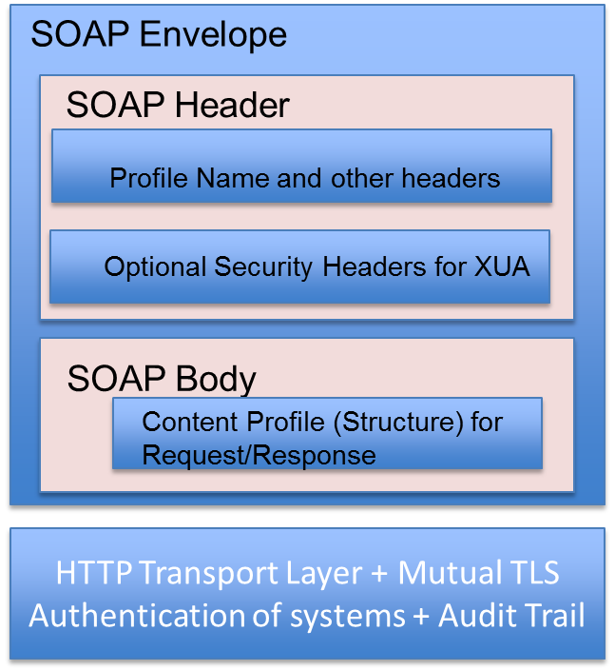

Figure 6-1: SOAP Stack Modular Components

The ability to introduce new content profiles in the query stack requires the following activities

* Create a new content profile following the IHE process
* Reuse the security and SOAP parts of the query stack as it is currently present.

The ability to introduce a new security profile in the query stack requires the following activities

* Create a new security profile compatible with the SOAP stack using the right SOAP WS-* specifications.
* Reuse the SOAP and content parts of the query stack as it is currently present.

The SOAP part of the stack includes the following components and is based on the Appendix V of IHE TF Volume TBD.

* SOAP 1.2 requirements
* WS-Addressing requirements
* MTOM and XOP requirements

It would be good to modularize the existing SOAP part to split the different requirements in a modular fashion because not all content profiles would require MTOM and/or XOP requirements.

The Transport requirements involve the use of HTTP along with Mutual TLS Authentication (Secure Node part of the ATNA profile) and the Audit Logging requirements.

## 6.4 Engineering Dimension

The IHE profiles identified provide sample deployment options specific to each profile. DAF uses multiple profiles and the following section identifies sample deployment models from a DAF perspective.

## 6.4.1 LDAF Deployment Model 1

In the deployment model shown below, both the Query Requestor and Query Responders are part of the same application within the enterprise.

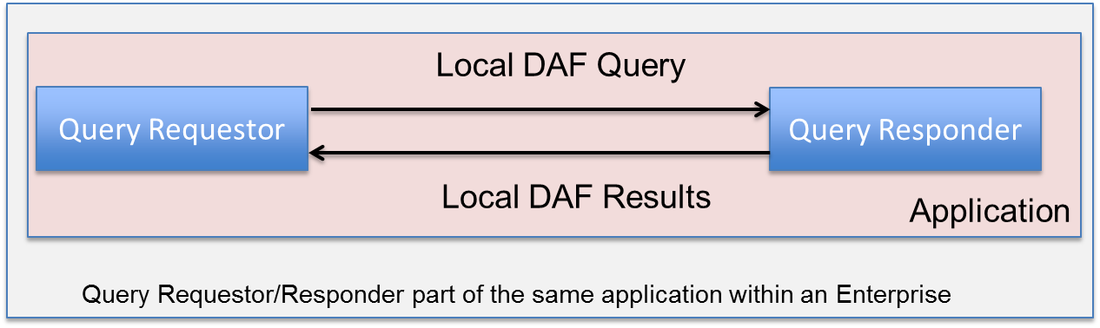

Figure 6-2: LDAF Deployment Model 1

## 6.4.2 LDAF Deployment Model 2

In the deployment model shown below, the Query Requestor and Query Responders are part of two different applications but within the same enterprise.

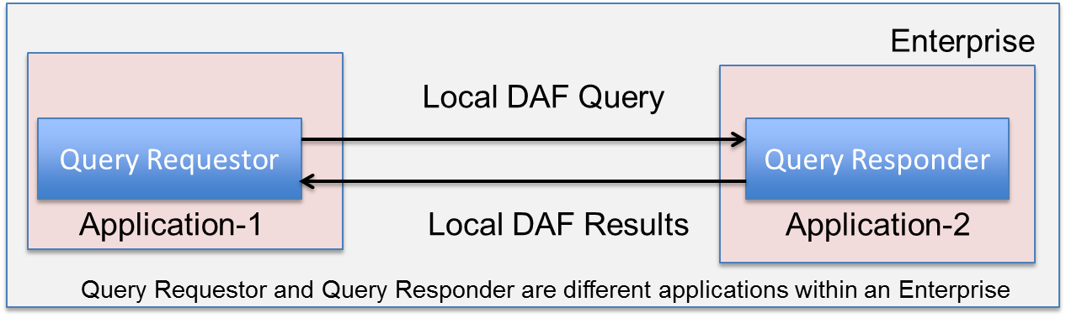

Figure 6-3: LDAF Deployment Model 2

## 6.4.3 TDAF Deployment Model

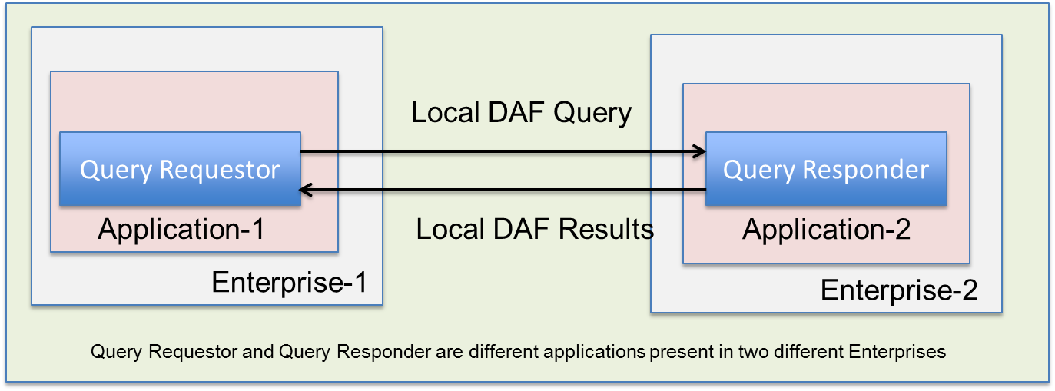

Figure 6-4: TDAF Deployment Model

# Conclusions

The white paper shows how SAIF was used to identify existing IHE profiles that can be used to meet DAF requirements along with any gaps that will have to be fulfilled. The figure below shows the various concrete sections of the documents that were created as part of the DAF white paper.

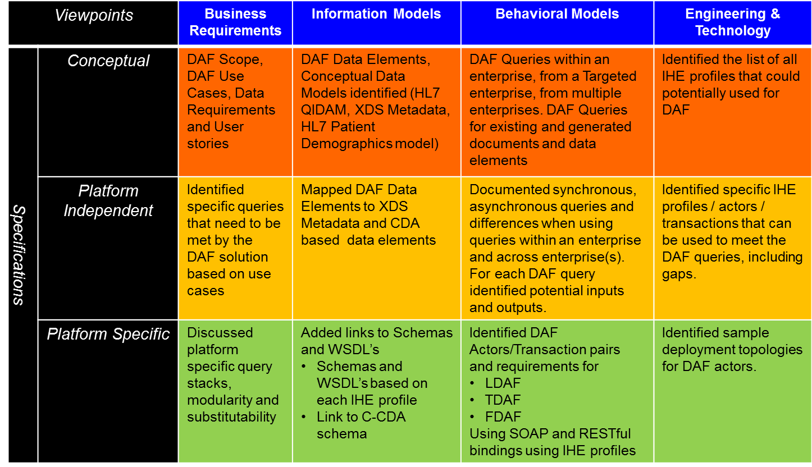

Figure 7-1: HL7 SAIF as applied to DAF

**The following conclusions can be drawn from the analysis of the existing IHE profiles.**

* For Local DAF Use Cases and Requirements
  + Document metadata based queries can be executed using both SOAP and RESTful transport stacks along with the relevant content profiles.
    - RESTful stack however does have limitations currently such as being able to retrieve one document at a time which may have to be removed for effective usage within a LDAF use case scenario.
  + Discovery of Patient Identifiers can be executed using the SOAP stack and the RESTful stack is being developed by IHE currently.
  + Data Element based queries can only be executed using the SOAP transport stack, however there are a few limitations in the data elements that can be queried and returned. (For e.g. Care Team Members, Free Text Search is not currently supported by QED profile). In addition there is no IHE RESTful alternative at this point in time.
  + SMTP stack is not used for queries widely and there are no current IHE profiles for queries using SMTP stack.
* For Targeted DAF and Federated DAF Use Cases and Requirements
  + Document metadata based queries can be executed using the SOAP transport stack along with the relevant content profiles.
    - RESTful stack is still evolving for Targeted and Federated Use Cases. Currently one could combine the RESTful profiles with other cross-community profiles such as XDS/XCA and be able to use the RESTful stack from a Query Requestor standpoint.
  + Discovery of Patient Identifiers can be executed using the SOAP stack.
    - RESTful stack is still evolving for Targeted and Federated Use Cases.
  + Data Element based queries can only be executed using the SOAP transport stack, however there are a few limitations in the data elements that can be queried and returned. (For e.g. Care Team Members, Free Text Search is not currently supported in the QED profile). In addition there is no IHE RESTful alternative at this point in time.
  + SMTP stack is not used for queries widely and there are no current IHE profiles for queries using SMTP stack.

# Next Steps

The following are discussion points for the F2F meeting before the next steps are finalized

* Ability to expand the existing IHE RESTful stack (MHD) to add support for multiple document retrieval similar to XDS/XCA.
* Ability to start RESTful profile to access data based on FHIR.
* Ability to use RESTful profiles for cross-enterprise transactions similar to SOAP.
* Ability to start population data access profile based on HQMF R2.

# Appendix A – Sample Integration Statements

The following are sample integration statements that could be used by vendors based on the above analysis for the purposes of DAF.

|  |  |  |  |
| --- | --- | --- | --- |
| Integration Statement | | Date | |
| Vendor | | Product Name | Version |
| Some XYZ Company | | My Health Care Product | Version 1.0 |
| This product implements the Local DAF Query Responder transactions using IHE profiles to support Document metadata based queries. | | | |
| DAF Execution Context | DAF Actors | DAF Transactions | IHE Profiles/Actors/Transactions implemented |
| LDAF | Query Responder | Find Patient Identifiers for Patient Demographics | [PIX/PDQv3](http://wiki.ihe.net/index.php?title=Patient_Demographics_Query_HL7_v3) - ITI 45, ITI 47 |
| Find Document(s) based on Patient Identifiers | [XDS](http://wiki.ihe.net/index.php?title=Cross_Enterprise_Document_Sharing) **–** ITI 18  [MHD](http://wiki.ihe.net/index.php?title=Mobile_access_to_Health_Documents) **–** ITI 66, ITI 67 |
| Get Document(s) based on Document Identifiers | [XDS](http://wiki.ihe.net/index.php?title=Cross_Enterprise_Document_Sharing) **–** ITI 43  [MHD](http://wiki.ihe.net/index.php?title=Mobile_access_to_Health_Documents) **–** ITI 68 |

# Appendix B – Sample User Stories

The User Stories represent real world examples of the data access framework. This section contains example user stories to illustrate the specific instances of the Data Access Framework use cases. By design the Data Access Framework is expected to support multiple user stories, many now unforeseen, and therefore the Appendix does not attempt to enumerate all possible uses.

## User Story#1(Document metadata based access - Patient Level Query)

**A Provider accesses clinical summary documents on an ad hoc basis for a new diabetic patient with**

**documented poor glucose control**

A new patient arrives to a small family practice in Boston, MA. The PCP sees a 48 year-old male, with Diabetes Mellitus Type I (DM I) diagnosis since age 12. The patient has a history of myocardial infarction (MI) at age 37 and a stroke at age 43. The patient admits that he often forgets to take his medication as prescribed and often forgets to check his blood sugar levels throughout the day. The patient travels for work and has been admitted to different ER’s numerous times for acute complications due to elevated blood sugar levels. All healthcare facilities where the patient was admitted generated clinical summaries and sent the information to patient’s new physician at the patient’s request. The clinical summaries have been stored in the local document repository database within the organization. ***For today’s visit, the physician’s practice generates an ad-hoc query in preparation for the patient’s arrival within the EHR to access all clinical summary documents produced locally and those received from other healthcare facilities, so that he can check if the patient’s HbA1c levels were greater than 7% and if the glucose levels were greater than 100mg/dL over the past 5 years the EHR system queries the document repository database to retrieve the requested information and sends back multiple clinical summary documents to the physician for additional review.*** This information provides the physician required context to understand the severity of circumstances that led to the patient’s ER admission, the severity of the patient’s non-adherence to medications and formulate a plan to improve the patient’s lifestyle and adherence to medications to mitigate future ER visits and reduce or prevent the progression of established comorbidities.

## User Story#2 (Document metadata based access - Patient Level Query)

**A provider needs to access information for one of his patients’ who recently moved to a new state and that has a new care team.**

A patient is moving from Michigan to Florida for retirement. The patient has diabetes and has also undergone multiple open heart surgeries to correct irregular heartbeats and other ailments related to the heart. His new care team in Florida is preparing for an initial visit and has requested the patient to retrieve his medical history from as many sources as possible. The patient approaches the Michigan hospital, the PCP and the cardiologist office who are part of the current care team and where he has received treatment before. ***He requests each one to provide his medical records (clinical documents) to date. The providers query each of their local EHR systems to obtain the clinical documents, requested by the patient****.* Now that the patient has all necessary records, he can carry them with him on his initial visit to a new care team in Florida.

## User Story#3 (Data Element based access - Patient Level Query)

**Physician referral to Endocrinologist within the same organization using different EHRs with system alerts for patient protected information**

In accordance with best practice, the Gastroenterologist orders fasting glucose lab tests for new or current Hepatitis C patients.  ***The Gastroenterologist’s EHR receives results from source systems based on queries*** which are set up to run automatically,and alerts him when a patient’s fasting glucose lab results are between 100 mg/dL and 125 mg/dL. During an initial encounter with a VA patient for Hep-C, the Gastroenterologist is alerted that the patient’s glucose intolerance lab results are very high. The Gastroenterologist wants to refer the patient to an Endocrinologist in his practice. ***In preparation for the referral, the Gastroenterologist queries the repository for all of the patient’s records including sensitive records disclosed to him by the VA per the patient’s consent. The Gastroenterologist receives a response to this query*** and is alerted that information related to the patient’s Hep-C, which was diagnosed during substance abuse treatment, is protected under Title 38, and may not be disclosed without patient consent. Before making the referral, the Gastroenterologist asks the patient whether she consents to disclose protected information to the Endocrinologist.  The patient agrees, and signs an electronic consent directive. The Gastroenterologist’s EHR updates the security labels on this patient’s protected information authorizing the Endocrinologist to query for her records. ***When the Endocrinologist’s EHR system queries Gastroenterologist’s EHR, it is authorized to receive the patient’s records including the Title 38 protected information. When researchers within the Endocrinologist’s practice query for Hepatitis C patients, they will not receive the results for patients who have not consented to disclosure for research, because they are not authorized*.**

## User Story#4 (Document metadata based access - Population level Query)

**PCP searches for office visit summaries in local EHR system to further analyze them using 3rd party software system (external to EHR) to understand severity of illness in patient population**

A primary care physician’s patient panel has a significant number of male patients who have cardiovascular disease and diabetes over the past 5 years.  She wants to further analyze the clinical summaries of her male patient population over the past 5 years using a 3rd party analytical application external to the EHR System. She queries her EHR system to retrieve clinical office summary visit documentation for patients over the past 5 years. The results of the query are returned to her in a structured document format for each of the patients fitting those criteria. Once she receives the results, she further analyzes the summaries by using an external 3rd party analytical application to break down cohorts of those patients with mild, moderate, and severe disease to determine who are missing recommended preventive and disease management services such as lab checks and diabetic foot exams.

User Story #5 (Data Element based access - Patient Level Query)   
**PCP searches for office visit summaries in local EHR system to further analyze them using 3rd party software system (external to EHR) to understand severity of illness in patient population**

A primary care physician’s patient panel has a significant number of male patients who have cardiovascular disease and diabetes over the past 5 years.  She already has a list of male patients and their clinical office visit summary documents that she was able to retrieve through a previous query search in her EHR. She wants to use that list of patients now to drill down within each of these documents to identify patients with cardiovascular disease and diabetes over the past 5 years.  The PCP sends one query to her EHR system for all identified patients to retrieve patients with diagnoses of cardiovascular disease and diabetes over the past 5 years. The query returns a list with associated documents that match the query request. Once she receives the results, she further analyzes the summaries by using an external 3rd party application to break down cohorts of those patients with mild, moderate, and severe disease to determine who is missing recommended preventive and disease management services such as lab checks and diabetic foot exams.

User Story#6 (Data Element based access – Patient Level Query)   
**PCP querying lab data results over past 12 months for a patient whose HbA1c is >7%**

A Primary Care Provider (PCP) at Virginia Family Medicine Center (VFMC) recently ordered an HbA1c test for a new patient with established Diabetes Type 1 diagnosis. The patient had been to VFMC several times before, but just recently switched her PCP internally at VFMC. The PCP received the test results for a specimen drawn on 7/5/2013 in her EHR system indicating that the patient’s HbA1c was 8.3%. Her PCP would like to determine her patient’s glucose level trend over the past 12 months. The PCP formulates a query in her EHR system to retrieve all HbA1c results where the patient’s levels were above 7% at VMFC. The PCP receives a single response of available results from one or more responding application(s) where this data was documented. The PCP is able to obtain all of the results requested from the responding application(s). Upon receiving the results, the PCP confirms that the patient’s glucose levels have been progressively increasing based on available results for each visit since 7/5/2012. The PCP then schedules a set of diagnostic tests to aid her in developing an effective rehabilitation plan to proactively manage her patient’s health condition.

User Story#7 (Document meta data based access - Patient Level Query)  
**Two applications share data during a hospital visit to coordinate information about diagnoses, medications and treatments and queuing of appropriate patient education and instruction material. (Debbie Foss Submitted on Wednesday September 5th, 2013)\**

A patient enters the hospital for pneumonia. During his visit, he is diagnosed with CHF. Patient instruction located in Application X queries the information from Application Y and receives patient demographics and admitting diagnosis, triggering a preliminary list of education topics for introduction to pneumonia and medications for in-hospital teaching. Application X then receives (either via query or as and alert) for the CHF diagnosis, and begins to queue topics for daily teaching on a new diagnosis, new medications and diet. Prior to discharge, Application X queries Application Y -- perhaps seeking a C-CDA in whatever state of completion it's available -- and topics for discharge instructions are triggered for compilation by providers.

User Story#8 (Data Element based access - Population level Query)  
**Physician conducts ad hoc query to determine percent of Hepatitis C patients for research at an organization under treatment with no fasting glucose lab tests (EHR to CDR)**

A new physician starts working at a health center where many patients with Hepatitis C are treated. The physician is aware of clinical practice guideline that specifies that patients with Hepatitis C diagnosis on active treatment must have fasting glucose test performed at the beginning of treatment and at predefined intervals during the treatment. The physician wants to conduct research on the quality assessment of patients being treated. The physician sets up a query to first identify all patients with a diagnosis of Hepatitis C and currently receiving Hepatitis C treatment that have not had a fasting glucose test since beginning of the therapy. The query is sent from the local EHR system to an identified application(s) (i.e. Clinical Data Repository) to retrieve a list of patient names fitting these criteria. Upon receiving this information back in his EHR system the physician learns that 3% of his Hepatitis C patients currently under treatment have not had their fasting glucose test. The physician then retrieves the list of individual patients who have consented to share their information for purposes of research.

User Story#9 (Data Element based access-Patient Level Query)  
**User Story Revised and Submitted by Nicole Antonson September 12th, 2013 Ancillary to EHR Query and Update (Pull and push)**

Dr. Jones admits patient J to the hospital for pneumonia. During patient J’s visit, he is diagnosed with angina. While in the hospital, he is scheduled for angiogram.  During preop, the cardiology nurse begins the data entry process into the cardiology system for the patient (e.g., completes assessment form.)  The nurse selects the patients name and the cardiology system initiates a query to the EHR for demographic and patient profile data (e.g., problems, meds and allergies.) The EHR returns the information, the cardiology system uses this information to populate the assessment form, and the nurse completes any missing information through a patient interview.  (During the assessment process the same information returned is used for decision support and reminders.)  During the angiogram, patient J requires angioplasty.  Medications are administered during the procedure and new ongoing orders are created.  After the procedure is closed, the Cardiology system pushes the administered medications and ongoing medications to the EHR.

# Appendix C – DAF Data Requirements

*The dataset requirements section identifies the data elements based on the use cases and are described at a conceptual level. The descriptions of the data elements are independent of any particular standard and will serve as the starting point for the harmonization activity. During the harmonization activity the data elements will be further refined and if necessary decomposed and will eventually be mapped to candidate standards. As a starting point these data elements have been derived from Meaningful Use Stage 2 core data elements and IHE XDS Metadata definitions.*

|  |  |  |
| --- | --- | --- |
| **Data Set Selection** | **Generic Data Element[10]** | **Generic Data Element Description** |
| **Time** | Document Creation Time | Date and Time stamp for document creation. |
| Service Start Time | The start time the service being documented took place. |
| Service End Time | The stop time the service being documented took place. |

|  |  |  |
| --- | --- | --- |
| **Data Set Selection** | **Generic Data Element[11]** | **Generic Data Element Description** |
| Patient Data | Patient ID | The identifier assigned by a provider or healthcare organization to a patient (example: MRN) |
| Patient Demographics | A set of demographic information about the patient. This information typically includes patient’s first and last name, sex, birth date, race, and ethnicity. |
| Patient Identifiers | ID assigned to a patient where the care was provided within the local organization, if different from Patient ID. |

|  |  |  |
| --- | --- | --- |
| **Data Set Selection** | **Generic Data Element[12]** | **Generic Data Element Description** |
| **Organization Data** | Author institution | Represents a specific healthcare facility where a document was authored. |
| Health Facility Information | Information about the organizational setting in which the clinical encounter was documented and where clinical act occurred. This includes (Name of facility, Type of facility, code of facility, ID of facility) |
| Source Organization Information | Information about the origin of the document (Name of the Organization, Type of organization Code of organization, ID of the organization ) |
| Practice Setting Information | Practice setting is the location where clinical care was provided and the document was created. (Name of the practice, Code associated with the type of practice, identifier associated with the type of practice) e.g., Family Practice, Laboratory Department, Radiology Department, Pulmonary Unit, Intensive Care Unit, etc. |
| Document Custodian | Organization legally responsible for the document |

|  |  |  |
| --- | --- | --- |
| **Data Set Selection** | **Generic Data Element[13]** | **Generic Data Element Description** |
| **Document Level Data** | Document Information | Information about the document where patient information has been recorded (code associated with document type, Name associated with the document type, IDs associated with the document) |
| Comments | Comments associated with the Document, free form text. |

|  |  |  |
| --- | --- | --- |
| **Data Set Selection** | **Generic Data Element[14]** | **Generic Data Element Description** |
| **Document Author** | Author Specialty | Represents a specific specialty of the author who created the document. For example, Primary Care Physician, Nurse Practitioner, Anesthesiologist, Cardiologist etc. |
| Author Contact Information | Represents the telecommunications address (e.g. phone, email, etc.) of the document author, intended to assist with automated routing of other messages intended for the document author. |

Table 1: Dataset Requirements for Document Metadata Based Query Request

***Note: The data elements in the following table are also applicable to document metadata query response, data element based query request and data element based query response.***

***Note:*** *This list includes an initial list of data elements from MU summary documents exchanged among providers and/or patients. This includes the "Common MU Data Set" plus other elements required in one or more of the summary documents, all of which use C-CDA. There are other MU2 data elements not included in the DAF list that are captured and stored within EHRs for functionality not related to information exchange (e.g., Family Health History, secure messaging information).*

**Legend**

|  |  |
| --- | --- |
| X | Query requests will be created using one or more of these data elements identified in the request parameter column |
| □ | Query responses will include some or all of the data elements identified in the response parameter column |

|  |  |  |
| --- | --- | --- |
|  | Query Input Parameter |  |
| Query Type or Name | e.g., multi-patient |  |
| Query Response Format | e.g., table, list |  |
| **Data Elements** | **Request Parameter** | **Parameter Response Value** |
| Patient (s) Identification | X Null for population Queries | □ Null for population Queries /De-ID/LDS |
| Provider Identification | X | □ |
| **Data Elements** | **Request Parameter** | **Parameter Response Value** |
| Facility / Source | X | □ |
| Encounter Type | X | □ |
| Date (Date Range) | X | □ |
| Confidentiality Information |  | □ |
| 1. Patient name[15] | X Null for population Queries | □ Null for population Queries /De-ID/LDS |
| 2. Sex | X | □ |
| 3. Date of birth | X | □ |
| 4. Race* | X | □ |
| 5. Ethnicity* | X | □ |
| 6. Preferred language* | X | □ |
| 7. Smoking status* | X | □ |
| 8. Problems* | X | □ |
| 9. Medications* | X | □ |
| **Data Elements** | **Request Parameter** | **Parameter Response Value** |
| 10. Medication allergies* | X | □ |
| 11. Laboratory test(s)* | X | □ |
| 12. Laboratory value(s)/result(s)* | X | □ |
| 13. Vital signs (height, weight, BP, BMI) | X | □ |
| 14. Care plan field(s), including goals and instructions | X | □ |
| 15. Procedures* | X | □ |
| 16. Care team members | X | □ |
| 17. Immunizations* | X | □ |
| 18. Confidentiality Information | No Confidentiality Code Query Parameter | □ |
| 19. Clinical Instructions[16] | X | □ |
| 20. Cognitive Status | X | □ |
| 21. Date and Location of Visit | X | □ |
| 22. Dates and Location of Admission and Discharge- Inpatient Only | X | □ |
| 23. Diagnostic Tests Pending | X | □ |
| 24. Discharge Instructions- Inpatient Only | X | □ |
| 25. Functional Status | X | □ |
| 26. Future Appointments | X | □ |
| 27. Future Scheduled Tests | X | □ |
| 28. Immunizations Administered during the Visit* | X | □ |
| 29. Medication List * | X | □ |
| 30. Medications Administered during the Visit* | X | □ |
| 31. Provider Name and Office Contact Information | X | □ |
| 32. Reason for Hospitalization- Inpatient Only | X | □ |
| 33. Reason for Referral- Ambulatory Only | X | □ |

|  |  |  |
| --- | --- | --- |
| **Data Elements** | **Request Parameter** | **Parameter Response Value** |
| 34. Reason for Visit | X | □ |
| 35. Recommended Patient Decision Aids | X | □ |
| 36. Referrals to other Providers | X | □ |

Table 7-1: Dataset Requirements for Document Metadata Based Query Response and Data Element Based Query Request and Response

# Appendix D – QIDAM UML Model Diagrams

The section captures the various UML models that are documented as part of the QIDAM. For the latest models please access <https://github.com/cnanjo/OneModel/blob/master/harmonized/QIDAM.eap>

## Core Model



## Entities Model



## Observable Model



## Enactable Model



## Enactable Medication



## Enactable Procedure



## Enactment Phase



## Statements – Adverse Event



## Statements – Condition



## Statements – Encounter



## Statements – Inference



## Statements – Medication



## Statements - Observation



## Statements – Procedure



1. **Note:** examples of data elements for document metadata based access can be found in the following types of profiles: [XDS](http://www.ihe.net/Technical_Framework/upload/IHE_ITI_TF_Rev8-0_Vol3_FT_2011-08-19.pdf), CDAR2
2. **Note:** examples of data elements for document metadata based access can be found in the following types of profiles: [XDS](http://www.ihe.net/Technical_Framework/upload/IHE_ITI_TF_Rev8-0_Vol3_FT_2011-08-19.pdf), CDAR2
3. **Note:** examples of data elements for document metadata based access can be found in the following types of profiles: [XDS](http://www.ihe.net/Technical_Framework/upload/IHE_ITI_TF_Rev8-0_Vol3_FT_2011-08-19.pdf), CDAR2
4. **Note:** examples of data elements for document metadata based access can be found in the following types of profiles: [XDS](http://www.ihe.net/Technical_Framework/upload/IHE_ITI_TF_Rev8-0_Vol3_FT_2011-08-19.pdf), CDAR2
5. **Note:** examples of data elements for document metadata based access can be found in the following types of profiles: [XDS](http://www.ihe.net/Technical_Framework/upload/IHE_ITI_TF_Rev8-0_Vol3_FT_2011-08-19.pdf), CDAR2
6. Note: In addition to using the actual data elements and their values, absence of data can be queried based on the platform specific implementation such as NullFlavors and Negation Indicators in HL7.
7. **Note:** Data Elements have been cited from EHR Certification Criteria and can be found [here](http://www.ecfr.gov/cgi-bin/text-idx?c=ecfr&SID=9d44a43faa41627b6ac100e53415884d&rgn=div8&view=text&node=45:1.0.1.4.80.3.27.5&idno=45).
8. Note: The following is a link to [US FACA HITPC recommendations to US ONC](http://www.healthit.gov/facas/sites/faca/files/IEWG_RecommendationTransmittal.pdf) regarding queries which may influence the usage of DAF in the United States.
9. Note: Most of the query request / response information was derived based on existing IHE profiles.
10. **Note:** examples of data elements for document metadata based access can be found in the following types of profiles: [XDS](http://www.ihe.net/Technical_Framework/upload/IHE_ITI_TF_Rev8-0_Vol3_FT_2011-08-19.pdf), CDAR2
11. **Note:** examples of data elements for document metadata based access can be found in the following types of profiles: [XDS](http://www.ihe.net/Technical_Framework/upload/IHE_ITI_TF_Rev8-0_Vol3_FT_2011-08-19.pdf), CDAR2
12. **Note:** examples of data elements for document metadata based access can be found in the following types of profiles: [XDS](http://www.ihe.net/Technical_Framework/upload/IHE_ITI_TF_Rev8-0_Vol3_FT_2011-08-19.pdf), CDAR2
13. **Note:** examples of data elements for document metadata based access can be found in the following types of profiles: [XDS](http://www.ihe.net/Technical_Framework/upload/IHE_ITI_TF_Rev8-0_Vol3_FT_2011-08-19.pdf), CDAR2
14. **Note:** examples of data elements for document metadata based access can be found in the following types of profiles: [XDS](http://www.ihe.net/Technical_Framework/upload/IHE_ITI_TF_Rev8-0_Vol3_FT_2011-08-19.pdf), CDAR2
15. **Note:** The initial list of data elements are derived from MU2 data elements whose definitions can be accessed [here](https://www.federalregister.gov/articles/2012/09/04/2012-20982/health-information-technology-standards-implementation-specifications-and-certification-criteria-for#t-2). Data elements numbered 1-18 are from the MU2 data elements.
16. **Note:** Data Elements in Blue Text have been cited from EHR Certification Criteria and can be found [here](http://www.ecfr.gov/cgi-bin/text-idx?c=ecfr&SID=9d44a43faa41627b6ac100e53415884d&rgn=div8&view=text&node=45:1.0.1.4.80.3.27.5&idno=45). Data elements numbered 19-36 are from the EHR Certification Criteria.